**Public Health Modernization in Oregon**

**Statewide public health modernization plan 2018 progress report - draft**

**Introduction**

Oregon leads in its approach to health system transformation, which aims to provide better health and better care at a lower cost. A transformed health system requires a strong governmental public health system that promotes and protects health outside of the clinical setting.

In 2015, the legislature passed House Bill 3100, which established a new framework for public health in Oregon. The public health modernization framework depicts a set of foundational public health programs and capabilities that ensure critical public health protections for everyone in Oregon. Since the passage of House Bill 3100, state and local public health authorities, under the guidance of the Public Health Advisory Board, have plotted a course toward modernization and are now implementing key components of public health modernization across the system.

**The Task Force for the Future of Public Health Services**

Oregon’s work to modernize the public health system began in 2013 with the Task Force for the Future of Public Health Services (Task Force). The Task Force was created by House Bill 2348 (2013) with the directive to provide recommendations for the future of public health in Oregon. In September 2014 the Task Force submitted a set of recommendations for modernizing the public health system to the legislature. These recommendations became the foundation for House Bill 3100 (2015), which established public health modernization as the framework for public health in Oregon.

See page XXX for a description of how the Task Force recommendations for modernizing Oregon’s public health system have been implemented since 2014.

**Progress made in 2017 on the Statewide Public Health Modernization Plan**

In December 2016, Oregon Health Authority, Public Health Division published the Statewide Public Health Modernization Plan. This plan, developed in consultation with the Public Health Advisory Board and local public health authorities, used findings from the 2016 statewide public health modernization assessment and our collective understanding of the current public health system to develop long-term strategies for modernizing the public health system over the next 6 to 10 years. This plan is available at [healthoregon.org/modernization](http://www.healthoregon.org/modernization).

The Statewide Public Health Modernization Plan is built on a roadmap of three key priorities. This progress report describes progress achieved on these roadmap priorities in 2017.

**Priority 1:** Improve the public health system’s capacity to provide foundational public health programs for every person in Oregon

* Strategy 1: Develop and implement a plan to phase in core public health functions, as described in the Public Health Modernization Manual, over the next three to five biennia. This roadmap serves as the initial plan.
* Strategy 2: Increase and use available funding to support implementation.
* Strategy 3: Apply a health equity and cultural responsiveness lens through all phases of implementation.
* Strategy 4: Work with Oregon’s federally recognized tribes to align tribal, state and local public health programs.
* Strategy 5: Create incentives for cross-jurisdictional collaborations
* (county-county/state-county) through the local public health funding formula and/or planning grants.
* Strategy 6: Establish a process to award state matching funds for county investments in foundational programs and capabilities through the local public health funding formula.
* Strategy 7: Ensure all LPHAs submit a comprehensive modernization plan by 2023.

Progress in 2017:

* **Regional communicable disease programs.**

For the 2017-19 biennium, the legislature made an initial investment of $5 million for modernizing Oregon’s public health system. In November Oregon Health Authority awarded $3.9 million to eight regional partnerships that will establish regional communicable disease programs. These regional partnerships span the state, with 34 of 36 counties involved in the establishment of a communicable disease control program.

* **Understanding and expanding the role of tribal health in public health modernization.**

Oregon Health Authority worked with Oregon’s tribes to conduct tribal health modernization assessments with (#) tribes. Conducting tribal health modernization assessments highlight where a tribe is providing foundational public health services and where there are opportunities for tribes and local public health to work together to determine how to provide services to the community. House Bill 2310 (2017) also added a tribal representative to the Public Health Advisory Board, bringing in this essential voice for guiding the direction of the public health system.

* **Expanding opportunities for cross jurisdictional sharing.**

Two groups of counties were awarded grants through the Center for Sharing Public Health Services. Each group worked on XXX…

* **Local modernization plans.**

AIMHI roadmap, leading to local modernization plans by 2023.

**Priority 2:** Align and coordinate public health and early learning, CCOs, hospitals, and other health partners and stakeholders for collective impact on health improvements

* Strategy 8: Establish new and innovative collaborative service delivery models with health care partners; scale and spread promising and best practices and effective models throughout the state.
* Strategy 9: Provide public health expertise and serve as the convener to support and promote evidenced-based prevention interventions across the health care and early learning sectors.
* Strategy 10: Align relevant public health priorities with OHA’s Action Plan for Health.
* Strategy 11: Adopt shared metrics and incentives with the early learning and health care delivery systems for collective impact.

Progress in 2017:

* **New partnerships with CCOs and other health system organizations.** Each regional partnership that has received funding includes at least one organization that is not a public health department. Three CCOs are included as partners, in addition to one regional health council and one health system. Builds infrastructure for local systems for communicable disease control that are shared across public health and the health care system.
* **Shared metrics.** In June, the Public Health Advisory Board adopted a set of eight accountability metrics that will be used to track Oregon’s progress toward meeting population health goals. More than half of the measures that were adopted align with CCO or early learning system metrics. Since adopting these measures, the Public Health Advisory Board has had multiple discussions with other metrics boards to discuss opportunities for aligned work. Shared priorities on common metrics.

**Priority 3:** Demonstrate progress toward improved health outcomes through accountability metrics and ongoing evaluation

* Strategy 12: Establish accountability metrics and incentives for population health outcomes.
* Strategy 13: Use the local public health funding formula to award performance-based payments to LPHAs that achieve benchmarks or improvement targets for accountability metrics.
* Strategy 14: Evaluate and report on the effectiveness and population health impact of new and existing service delivery models.

Progress in 2017:

* **Public Health Accountability Metrics.** Oregon Health Authority will release a baseline public health accountability metrics report in 2018. This report will show where we’re currently at with each population health priority as well as describe the essential role and function of local public health to make progress for each accountability metric.

Oregon Health Authority and local public health authorities have been working to revise the current Program Elements to align with core functions, roles and deliverables in the Public Health Modernization Manual and with public health accountability metrics. Revised Program Elements will be in effect beginning in July 2018.

* **Public health modernization evaluation.** In December Oregon Health Authority convened stakeholders to design the public health modernization evaluation for 2017-19. The final evaluation plan will be complete by the end of January 2018

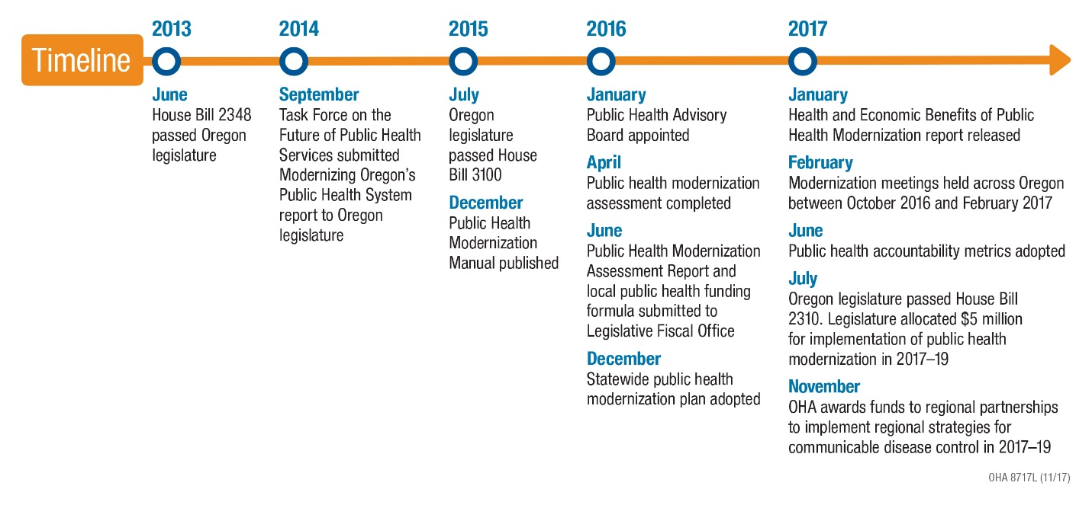

**The Task Force for the Future of Public Health Services**

The following table shows the Task Force recommendations that were submitted to the legislature in September 2014 and how these recommendations have been implemented.

|  |  |  |
| --- | --- | --- |
| **Task Force recommendations** | **Implementation in 2015-17** | **Implementation in 2017-19** |
| A defined set of Foundational Capabilities & Programs be adopted in all public health agencies in order for the public health system to function efficiently and effectively. | HB 3100 (2015) established a set of foundational capabilities and foundational programs for Oregon’s public health system.  State and local public health authorities jointly developed the Public Health Modernization Manual, which describes the core functions, roles and deliverables for each foundational capability and program. | State and local public health authorities are using the 2017-19 legislative investment for :   * The foundational program of communicable disease control * The foundational capability of assessment and epidemiology. Funds are supporting core population surveillance and enhancement of data systems. |
| Significant and sustained state funding for the governmental public health system be identified and allocated for proper operationalization of the Foundational Capabilities and Programs. | State and local public health authorities completed a public health modernization assessment which showed the system’s current capacity to implement foundational capabilities and programs and an estimated cost for full implementation.  The Public Health Advisory Board completed an initial public health modernization funding formula.  The Oregon Health Authority submitted the public health modernization funding formula and an estimated funding amount needed to implement public health modernization in 2017-19 to Legislative Fiscal Office. | The legislature made an initial investment of $5 million to implement public health modernization.  The Public Health Advisory Board will update the public health modernization funding formula, incorporating mechanisms for incentive payments and state matching funds to local public health authorities.  Oregon Health Authority will submit this funding formula, an estimated amount needed to expand implementation of public health modernization in 2019-21, and a description of the work that was funded in 2017-19 to Legislative Fiscal Office. |
| Statewide implementation of the Foundational Capabilities & Programs occur in waves | The Public Health Advisory Board developed a phased approach for implementing foundational capabilities and programs over three biennia.  Oregon Health Authority developed the Statewide Public Health Modernization Plan, which includes a roadmap for modernizing the public health system over the next 6 to 10 years. | The Public Health Advisory Board will update its recommended phased approach for implementing foundational capabilities and programs. |
| Local jurisdictions will have flexibility when operationalizing Foundational Capabilities & Programs. | The Conference of Local Health Officials (CLHO) held 10 regional modernization meetings in 2016-17. Meetings were used to identify existing cross jurisdictional sharing relationships, opportunities to expand CJS, and barriers to CJS.  CLHO used findings from these meetings to develop a set of tools for LPHAs to use to develop and expand CJS. This set of tools supports the development of local public health modernization plans. | Local public health authorities formed regional partnerships to establish regional communicable disease control programs.  Local public health authorities will use the tools developed by CLHO to expand the use of CJS. |
| Improvements and changes in the governmental public health system be structured around state and local metrics. These metrics will be established and evaluated by the Public Health Advisory Board, which will report to the Oregon Health Policy Board. | The newly comprised Public Health Advisory Board began meeting in January 2016 and has been meeting monthly since then. The board maintains oversight of public health modernization and other public health strategic initiatives.  The Public Health Advisory Board adopted a set of public health accountability metrics and corresponding local public health process measures. | Oregon Health Authority will publish a baseline public health accountability metrics report in 2018.  Oregon Health Authority and the Public Health Advisory Board will seek opportunities to support collaborations between the public health and health care sectors to achieve shared metrics. |