

Statewide Public Health Modernization Plan: 2017 Progress Report

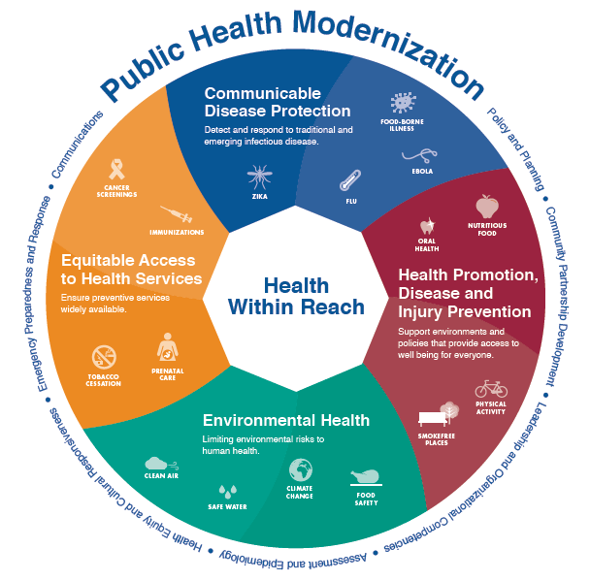

Oregon leads in its approach to health system transformation, which aims to provide better health and better care at a lower cost. A transformed health system requires a strong governmental public health system that promotes and protects health outside of the clinical setting.

Under legislative direction since 2013, state and local public health authorities have plotted a course and are now implementing key components of public health modernization.

**The Statewide Public Health Modernization plan 2017 progress report**

In December 2016, Oregon Health Authority, Public Health Division published the Statewide Public Health Modernization Plan. This plan, developed in consultation with the Public Health Advisory Board and local public health authorities, describes the long-term strategies for modernizing the public health system.

This progress report highlights progress toward the statewide public health modernization plan’s three overarching priorities in 2017.

**Priority 1:** Improve the public health system’s capacity to provide foundational public health programs for every person in Oregon

* **Regional communicable disease programs.** For the 2017-19 biennium, the legislature made an initial investment of $5 million for modernizing Oregon’s public health system. In November, Oregon Health Authority awarded $3.9 million to eight regional partnerships to establish regional communicable disease programs. These regional partnerships span the state, with 34 of 36 counties involved in the establishment of a communicable disease control program.
* **Tribal public health modernization assessments.** Oregon Health Authority worked with Oregon’s tribes to conduct tribal public health modernization assessments with three tribes and the Northwest Portland Area Indian Health Board. These assessments highlight each tribe’s role to provide foundational public health services and are a tool for tribes that would like to engage in planning with local public health authorities about how best to serve their common communities. House Bill 2310 (2017) added a tribal representative to the Public Health Advisory Board, bringing in a tribal perspective for guiding the direction of the public health system.
* **Local modernization plans.** The Conference of Local Health Officials (CLHO) developed an online public health modernization toolkit for local public health authorities. This toolkit provides resources and tools that support the development of local modernization plans by 2023.

**Priority 2:** Align and coordinate public health and early learning, CCOs, hospitals, and other health partners and stakeholders for collective impact on health improvements

* **New and enhanced partnerships with CCOs and other health system organizations.** Each regional partnership that received 2017-19 modernization funding includes at least one organization that is not a public health department, such as CCOs, health systems and regional health equity coalitions.
* **Shared metrics.** In June, the Public Health Advisory Board adopted a set of eight accountability metrics that will be used to track Oregon’s progress toward meeting population health goals. More than half of the measures that were adopted align with CCO or early learning system metrics.

**Priority 3:** Demonstrate progress toward improved health outcomes through accountability metrics and ongoing evaluation

* **Public Health Accountability Metrics.** Oregon Health Authority will release a baseline public health accountability metrics report in 2018. In addition to showing current data on population health priorities, the report will describe the local public health role to make progress for each accountability metric. Contracts between Oregon Health Authority and local public health authorities are being revised to include public health accountability metrics where they align with existing funding streams.
* **Public health modernization evaluation.** In December Oregon Health Authority convened stakeholders to design the public health modernization evaluation for 2017-19.

For more information about Oregon’s approach to modernizing the public health system, visit [healthoregon.org/modernization](http://www.healthoregon.org/modernization).

**The Task Force for the Future of Public Health Services**

Oregon’s work to modernize the public health system began in 2013 with the Task Force for the Future of Public Health Services (Task Force). The Task Force was created by House Bill 2348 (2013) with the directive to provide recommendations for the future of public health in Oregon. In September 2014 the Task Force submitted a set of recommendations for modernizing the public health system to the legislature. These recommendations became law in 2015.

The following table describes how the Task Force recommendations have been carried forward in Oregon’s approach to modernizing the public health system.

|  |  |  |
| --- | --- | --- |
| Task Force recommendations and HB 3100 (2015) | Implementation in 2015-17 | Implementation in 2017-19 |
| A defined set of foundational capabilities and programs be adopted in all public health agencies in order for the public health system to function efficiently and effectively. | HB 3100 (2015) established a set of foundational capabilities and foundational programs for Oregon’s public health system.  State and local public health authorities jointly developed the Public Health Modernization Manual, which defines each foundational capability and program. | HB 2310 further refined implementation of public health modernization.  State and local public health authorities are using the 2017-19 legislative investment for:   * Communicable disease control; * Health equity and cultural responsiveness; * Assessment and epidemiology. |
| Significant and sustained state funding for the governmental public health system be identified and allocated for proper operationalization of the foundational capabilities and programs. | State and local public health authorities completed a public health modernization assessment which showed the system’s current capacity and an estimated cost for full implementation.  The Public Health Advisory Board (PHAB) completed an initial public health modernization funding formula and the Oregon Health Authority (OHA) submitted the formula to Legislative Fiscal Office. | The legislature made an initial investment of $5 million to implement public health modernization.  PHAB will update the public health modernization funding formula, which will be submitted to Legislative Fiscal Office in June 2018. |
| Statewide implementation of the foundational capabilities and programs occur in waves | PHAB developed a phased approach for implementing foundational capabilities and programs over three biennia.  OHA developed the Statewide Public Health Modernization Plan. | PHAB will update its recommended phased approach for implementing foundational capabilities and programs. |
| Local jurisdictions will have flexibility when operationalizing foundational capabilities and programs. | The Conference of Local Health Officials (CLHO) held 10 regional modernization meetings in 2016-17. Meetings were used to discuss opportunities for sharing services across multiple counties.  CLHO used findings from these meetings to develop a set of tools for local public health authorities (LPHAs) to use to develop and expand shared services. | LPHAs formed regional partnerships to establish regional communicable disease control programs.  LPHAs will use the tools developed by CLHO to expand the use of shared services |
| Improvements and changes in the governmental public health system be structured around state and local metrics. These metrics will be established and evaluated by the Public Health Advisory Board, which will report to the Oregon Health Policy Board. | The newly comprised PHAB began meeting in January 2016 and has met monthly since then. PHAB is a committee of the Oregon Health Policy Board  PHAB adopted a set of public health accountability metrics and corresponding local public health process measures. | OHA will publish a baseline public health accountability metrics report in 2018. |

**Timeline for public health modernization**

