  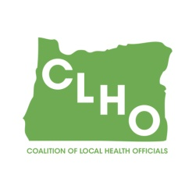 | CLHO Preparedness Committee  Conference Call or in PSOB Room 425  9/27/2017  9:00 – 11:00  Conference Call-In Number: 1- 888-273-3658  Participant Code: 448252  Agenda
Agenda Item |  | Presenter |  | Time
Welcome and roll call |  | Sue Mohnkern / Emily Wegener |  | 5 minutes
Request for volunteer note taker for next call (Selene volunteered for this meeting. Thank you! ) |  | Emily Wegener
Review of Minutes |  | Sue Mohnkern |  | 5 minutes
State Updates: TBD by DeWayne
Partner Assignment check-in |  | All |  | 5 minutes
Budget Proposal and discussion |  | Sue/All |  | 15 minutes
Wildfire Season Wrap-up |  | Emily/All |  | 5 minutes
CLHO PHEP Spring Retreat? |  | Emily/All |  | 5 minutes
Round Robin |  | Group |  | 10 minutes
Other discussion/issues/topics for next meeting |  | Group |  | 10 minutes
Next Meeting, October 25th, 9:00-11:00AM
Co-Chair  Emily Wegener  Jefferson County Public Health Preparedness and Healthy Communities Coordinator  541-325-5001 ext. 4227 /emily.wegener@co.jefferson.or.us |  |  | Co-Chair  Sue Mohnkern, MPH, RN, BSN  Washington County Public Health Program Supervisor  503-846-4902 / sue_mohnkern@co.washington.or.us
Public Health Division Staff:
DeWayne Hatcher, Interim Operations Chief
971-673-1038 / dewayne.r.hatcher@state.or.us

