  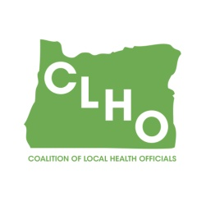 | CLHO Preparedness Committee  Conference Call or in PSOB Room 425  8/30/2017  9:00 – 11:00  Conference Call-In Number: 1- 888-273-3658  Participant Code: 448252  Agenda
Agenda Item |  | Presenter |  | Time
Welcome and roll call |  | Sue Mohnkern / Tom Kuhn |  | 5 minutes
Request for volunteer note taker |  | all
Review of Minutes |  |  |  | 5 minutes
State Updates:
Connections survey update and discussion of next steps |  | DeWayne and all |  | 10 minutes
Climate Change Survey |  | all |  | 5 minutes
Eclipse Activity Update |  | Morgan Feld |  | 5 minutes
Budget Group discussion |  | Sue and budget group |  | 15 minutes
Nominations for Co-Chair |  | All – don’t be shy! |  | 5 minutes
Round Robin |  | Group |  | 10 minutes
Other discussion/issues/topics for next meeting |  | Group |  | 10 minutes
Next Meeting , 9:00-11:00AM
Chair  Tom Kuhn, M.S.Ed., Community Health Manager  Deschutes County Health Services  541-322-7410 / thomas.kuhn@deschutes.org |  |  | Co-Chair  Sue Mohnkern, MPH, RN, BSN  Washington County Public Health Program Supervisor  503-846-4902 / sue_mohnkern@co.washington.or.us
Public Health Division Staff:
DeWayne Hatcher, Interim Operations Chief
971-673-1038 / dewayne.r.hatcher@state.or.us

