  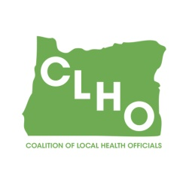 | CLHO Preparedness Committee  Conference Call or in PSOB Room 425  10/25/2017  9:00 – 11:00  Conference Call-In Number: 1- 888-273-3658  Participant Code: 448252  Agenda
Agenda Item |  | Presenter |  | Time
Welcome and roll call |  | Sue Mohnkern / Emily Wegener |  | 5 minutes
Confirmation of volunteer note taker (Kellen volunteered for this meeting, Jenny for November – thank you both!) |  | Sue
Review of Minutes |  | Emily/Sue |  | 5 minutes
State Updates: |  | DeWayne
Partner Assignment check-in |  | All |  | 5 minutes
Budget Proposal and discussion (see spreadsheet) |  | Sue/All |  | 45 minutes
Wildfire AAR report |  | Selene and Tanya |  | 5 minutes
Access and Functional Needs work, Long Term Care outreach (as time allows) |  | All |  | 15 minutes
CLHO PHEP Spring Retreat? |  | Emily/All |  | 5 minutes
Round Robin |  | Group |  | 10 minutes
Other discussion/issues/topics for next meeting |  | Group |  | 10 minutes
Next Meeting, Nov. 22nd, 9:00-11:00AM
Co-Chair  Emily Wegener  Jefferson County Public Health Preparedness and Healthy Communities Coordinator  541-325-5001 ext. 4227 /emily.wegener@co.jefferson.or.us |  |  | Co-Chair  Sue Mohnkern, MPH, RN, BSN  Washington County Public Health Program Supervisor  503-846-4902 / sue_mohnkern@co.washington.or.us
Public Health Division Staff:
DeWayne Hatcher, Interim Operations Chief
971-673-1038 / dewayne.r.hatcher@state.or.us

