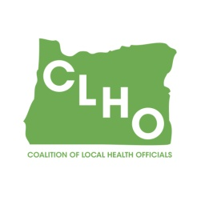   | CLHO Preparedness Committee  Conference Call or in PSOB Room 425  6/28/2017  9:00 – 11:00  Conference Call-In Number: 1- 888-273-3658  Participant Code: 448252  Agenda
Agenda Item |  | Presenter |  | Time
Welcome and roll call |  | Sue Mohnkern / Tom Kuhn |  | 5 minutes
Review of Minutes – May 2017 |  | Sue Mohnkern / Tom Kuhn |  | 5 minutes
Membership – Vacancies and Co-Chair position |  | Tom Kuhn |  | 10 minutes
Situation Status Subgroup Report |  | DeWayne Hatcher |  | 20 minutes
CLHO PHEP Outreach Survey response update |  | DeWayne Hatcher |  | 2 minutes
Partner “Assignments” |  | Sue Mohnkern |  | 5 minutes
Budget Committee Update? |  | Budget Committee |  | 15 minutes
Round Robin |  | Group |  | 10 minutes
Other discussion/issues/topics for next meeting |  | Group |  | 10 minutes
Next Meeting July 26, 2017, 9:00-11:00AM
Co-Chair  Tom Kuhn, M.S.Ed., Community Health Manager  Deschutes County Health Services  541-322-7410 / thomas.kuhn@deschutes.org |  |  | Co-Chair  Sue Mohnkern, MPH, RN, BSN  Washington County Public Health Program Supervisor  503-846-4902 / sue_mohnkern@co.washington.or.us
Public Health Division Staff:
DeWayne Hatcher, Interim Operations Chief
971-673-1038 / dewayne.r.hatcher@state.or.us

