  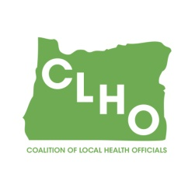 | CLHO Preparedness Committee  Conference Call or in PSOB Room 425  5/24/2017  9:00 – 11:00  Conference Call-In Number: 1- 888-273-3658  Participant Code: 448252  Agenda
Agenda Item |  | Presenter |  | Time
Welcome and roll call |  | Sue Mohnkern / Tom Kuhn |  | 5 minutes
Review of Minutes – March 2017 |  |  |  | 5 minutes
State Updates:
Budget Committee Update |  | Budget Committee |  | 10 minutes
SitStat Reporting Form Update |  | DeWayne |  | 2 minutes
Networking suggestion |  | Sue |  | 5 minutes
Sharing of “pearls” from April conferences |  | All who went |  | 15 minutes
Round Robin |  | Group |  | 10 minutes
Other discussion/issues/topics for next meeting |  | Group |  | 10 minutes
Next Meeting Mar. 22, 2017, 9:00-11:00AM
Chair  Tom Kuhn, M.S.Ed., Community Health Manager  Deschutes County Health Services  541-322-7410 / thomas.kuhn@deschutes.org |  |  | Co-Chair  Sue Mohnkern, MPH, RN, BSN  Washington County Public Health Program Supervisor  503-846-4902 / sue_mohnkern@co.washington.or.us
Public Health Division Staff:
DeWayne Hatcher, Interim Operations Chief
971-673-1038 / dewayne.r.hatcher@state.or.us

