  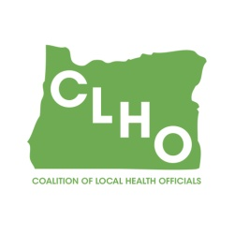 | CLHO Preparedness Committee  PSOB Room 425  March 25, 2015  9:00 – 11:00  Agenda  Conference Call-In Number: 1-888-273-3658  Participant Code: 448252  To Register for the Webinar:  Registration URL: https://attendee.gotowebinar.com/register/6243129642480989953  Webinar ID: 125-444-755
Agenda Item |  |  | Presenter | Time
Welcome - Introductions |  |  | Tom & Eugene | 5 minutes
Assignment of Minute Taker |  |  | Tom & Eugene | 1 minute
Review of Minutes – January 28 & February 11, 2015 meetings |  |  | Tom & Eugene | 5 minutes
Review of outstanding items from previous meeting |  |  | Tom & Eugene | 5 minutes
CLHO Preparedness webpage update |  |  | Uei Lei | 5 minutes
PE 09 – Ebola funding |  |  | Mike Harryman | 15 minutes
PE 12 update |  |  | Mike Harryman | 15 minutes
BP03 vs BP04 funding |  |  | Mike Harryman | 15 minutes
Open Discussion |  |  | Group
Next Meeting: April 22, 2015, 9:00-11:00AM
Contact Information:  Akiko Saito , Operations Chief  971-673-1363 / Akiko.Saito@state.or.us |  | Christina Stenerson , Administrative Specialist  971-673-1110 / christina.a.stenerson@state.or.us
Co-Chair  Eugene Regan, REHS, Preparedness Coordinator  Douglas County Health & Social Services  541-440-3568 / ewregan@co.douglas.or.us |  | Co-Chair  Tom Kuhn, M.S.Ed., Community Health Manager  Deschutes County Health Services  541-322-7410 / thomas.kuhn@deschutes.org

