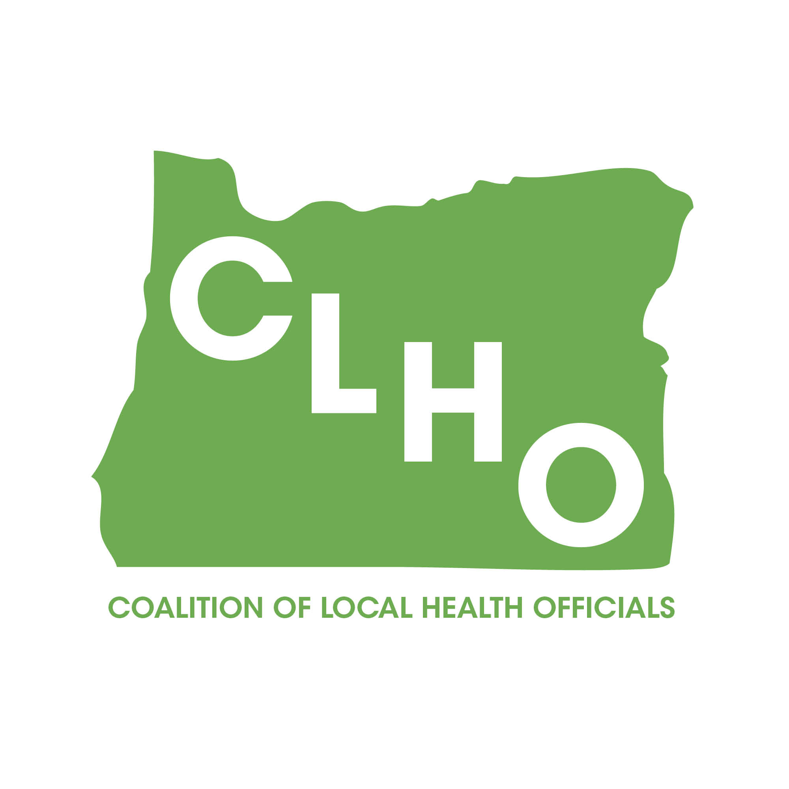 | CLHO Health Families Agenda  Portland State Office Building  ROOM 918  12:00-3:00 PM  June 17, 2015 | Join the meeting at:  https://www2.gotomeeting.com/join/180903602  Join the conference call:  1-888-273-3658  Participant code: 256313  Meeting ID: 180-903-602
CoChairs: Lindsey Manfrin | 503-846-3712 manfrinl@co.yamill.or.us
Judy Cleave | 503-361-2693 jcleave@co.marion.or.us

MINUTES
Agenda Item | Detail | Action Item | Responsible Party
Welcome & Introductions | Full introductions will be done after Morgan Cowling presents, since Morgan is due at a committee meeting soon after noon. | NA | NA
TCM/County Leveraged Funds  10 Minutes | Morgan will discuss delay in implementation. | Morgan was not able to make it. | Morgan Cowling
Full Introductions  All | Intro of Ann Ackles from Jackson county. She is the public health nursing supervisor for MCH.
Review meeting minutes from 4/15/15 | Brief review of meeting minutes | Approved by consensus. No action required. | NA
Rules Advisory Committee Representative  Rosalyn Liu  (5 Minutes) | Rosalyn needs a representative to sit on a Rules Advisory Committee regarding an update that the SBHC staff is making to their Certification rules. They are simply updating the Certification Standards referenced in the rules from 2013 to 2014. The change has already been accepted as an emergency temporary rules change, but they need to go through the formal permanent process now. Working off of new standards but still referencing 2013 standards. Change needs to be made permanent prior to October. | Discussion that best options might be designees rather than someone from this CLHO comm. Agreement that Rosalyn would send email to Jessica and/or discuss with someone in Multonamah county who is the right fit. Committee agrees to support a designee assignment if one can be found. | Rosalyn Liu
PE 41 Revisions  Helene Rimberg  (10 Minutes) | Revisions have been made in PE 41 to reflect the impact that subcontracting Family Planning services will have on local health departments. States desire is to make a plan that can be used in the future to help counties that may be subcontracting out in the future. State wants to be clear that still available and want to be supportive and help where needed but the needs vary from one county to another. Goal not to be too restrictive but that some clear cut guidelines and timelines might actually help some counties to get things to happen more quickly. | Concerns were brought forward that we did not need to reinvent the wheel there are many programs that have been subcontracting for years and that those rules should apply to Title X programs subcontracting as well. The monitoring and training expectations are not really different than what the county had to do when it was providing their own Title X services. Much discussion that this will likely be occurring more and that it is valuable to develop a committee to work on these revisions so they help the counties not hurt them. Committee agreed to try to find appropriate members in the county as designees if not official CLHO members. Helene will send an email invitation soliciting participation in a small workgroup for PE 41. | Helene Rimberg
Title V Block Grant  Cate Wilcox (15 Min) | Documents reflecting Title V service focus changes and funding changes along with the time frame for implementation of changes will be reviewed. Please refer to documents sent via email 6/12/15. Documents reviewed and counties will have some funding changes related to change in allocation of funds. | Reminder to counties that activities using Title V funds need to be directed at new priorities. Would like to develop some work groups in the fall to look at activities appropriate for each priority and are again looking for volunteers. Next meeting plan to have an outline of specifics so we can agree to work with certain groups. Nurit will guide this discussion. Funding changes for FY 15/16 reviewed. Some counties will see an increase in funds; others will see a decrease in funds the second half of the year. Cate and Nurit will provide this same information at the full CLHO meeting tomorrow. | Cate Wilcox  Nurit Fischler
Acronyms:

CLHO HEALTHY FAMILIES COMMITTEE
ATTENDANCE ROSTER
June 17, 2015

State Reps |  | Interested Parties |  | Interested Parties:
Cate Wilcox | x | Adrienne Greene |  | Renee Hackenmiller-Paradis
Susan Woodbury | x | Anna Stiefvater | x | Rebecca Strickler
 |  | Benjamin Hazelton |  | Robin Stanton
 |  | Beth Gebstadt |  | Ronit Zusman
Local Reps |  | Caroline Neunzert |  | Rosalyn Liu | x
Ann Ackles | x | Carrie Brogotti |  | Ruth Harshfield
Arielle LeVeaux |  | Cheryl Alto |  | Terra Frenken
Cathy Perry |  | Cynthia Ikata | x
Dawnelle Marshall | x | Dana Hargunani
Holly Strahm |  | Francine Goodrich
Jessica Guernsey | x | Helene Rimberg | x
Judy Cleave | x | Isabelle Barbour
Kathy Devoss |  | Jackie Harris
Lindsey Manfrin |  | Jan Kaplan | x
Norma O’Mara | x | Jennifer Young
Pamela Ferguson |  | Jessica Duke
Shelly Paeth |  | Kathy Christiansen
Susan Pinnock | x | Lari Peterson | x
Teri Thalhofer |  | Lesa Dixon Gray
 |  | Marilyn Hartzell
 |  | Marti Baird | x
 |  | Maikia Moua | x
 |  | Morgan Cowling | x
 |  | Nurit Fischler
 |  | Rebecca Pollock

