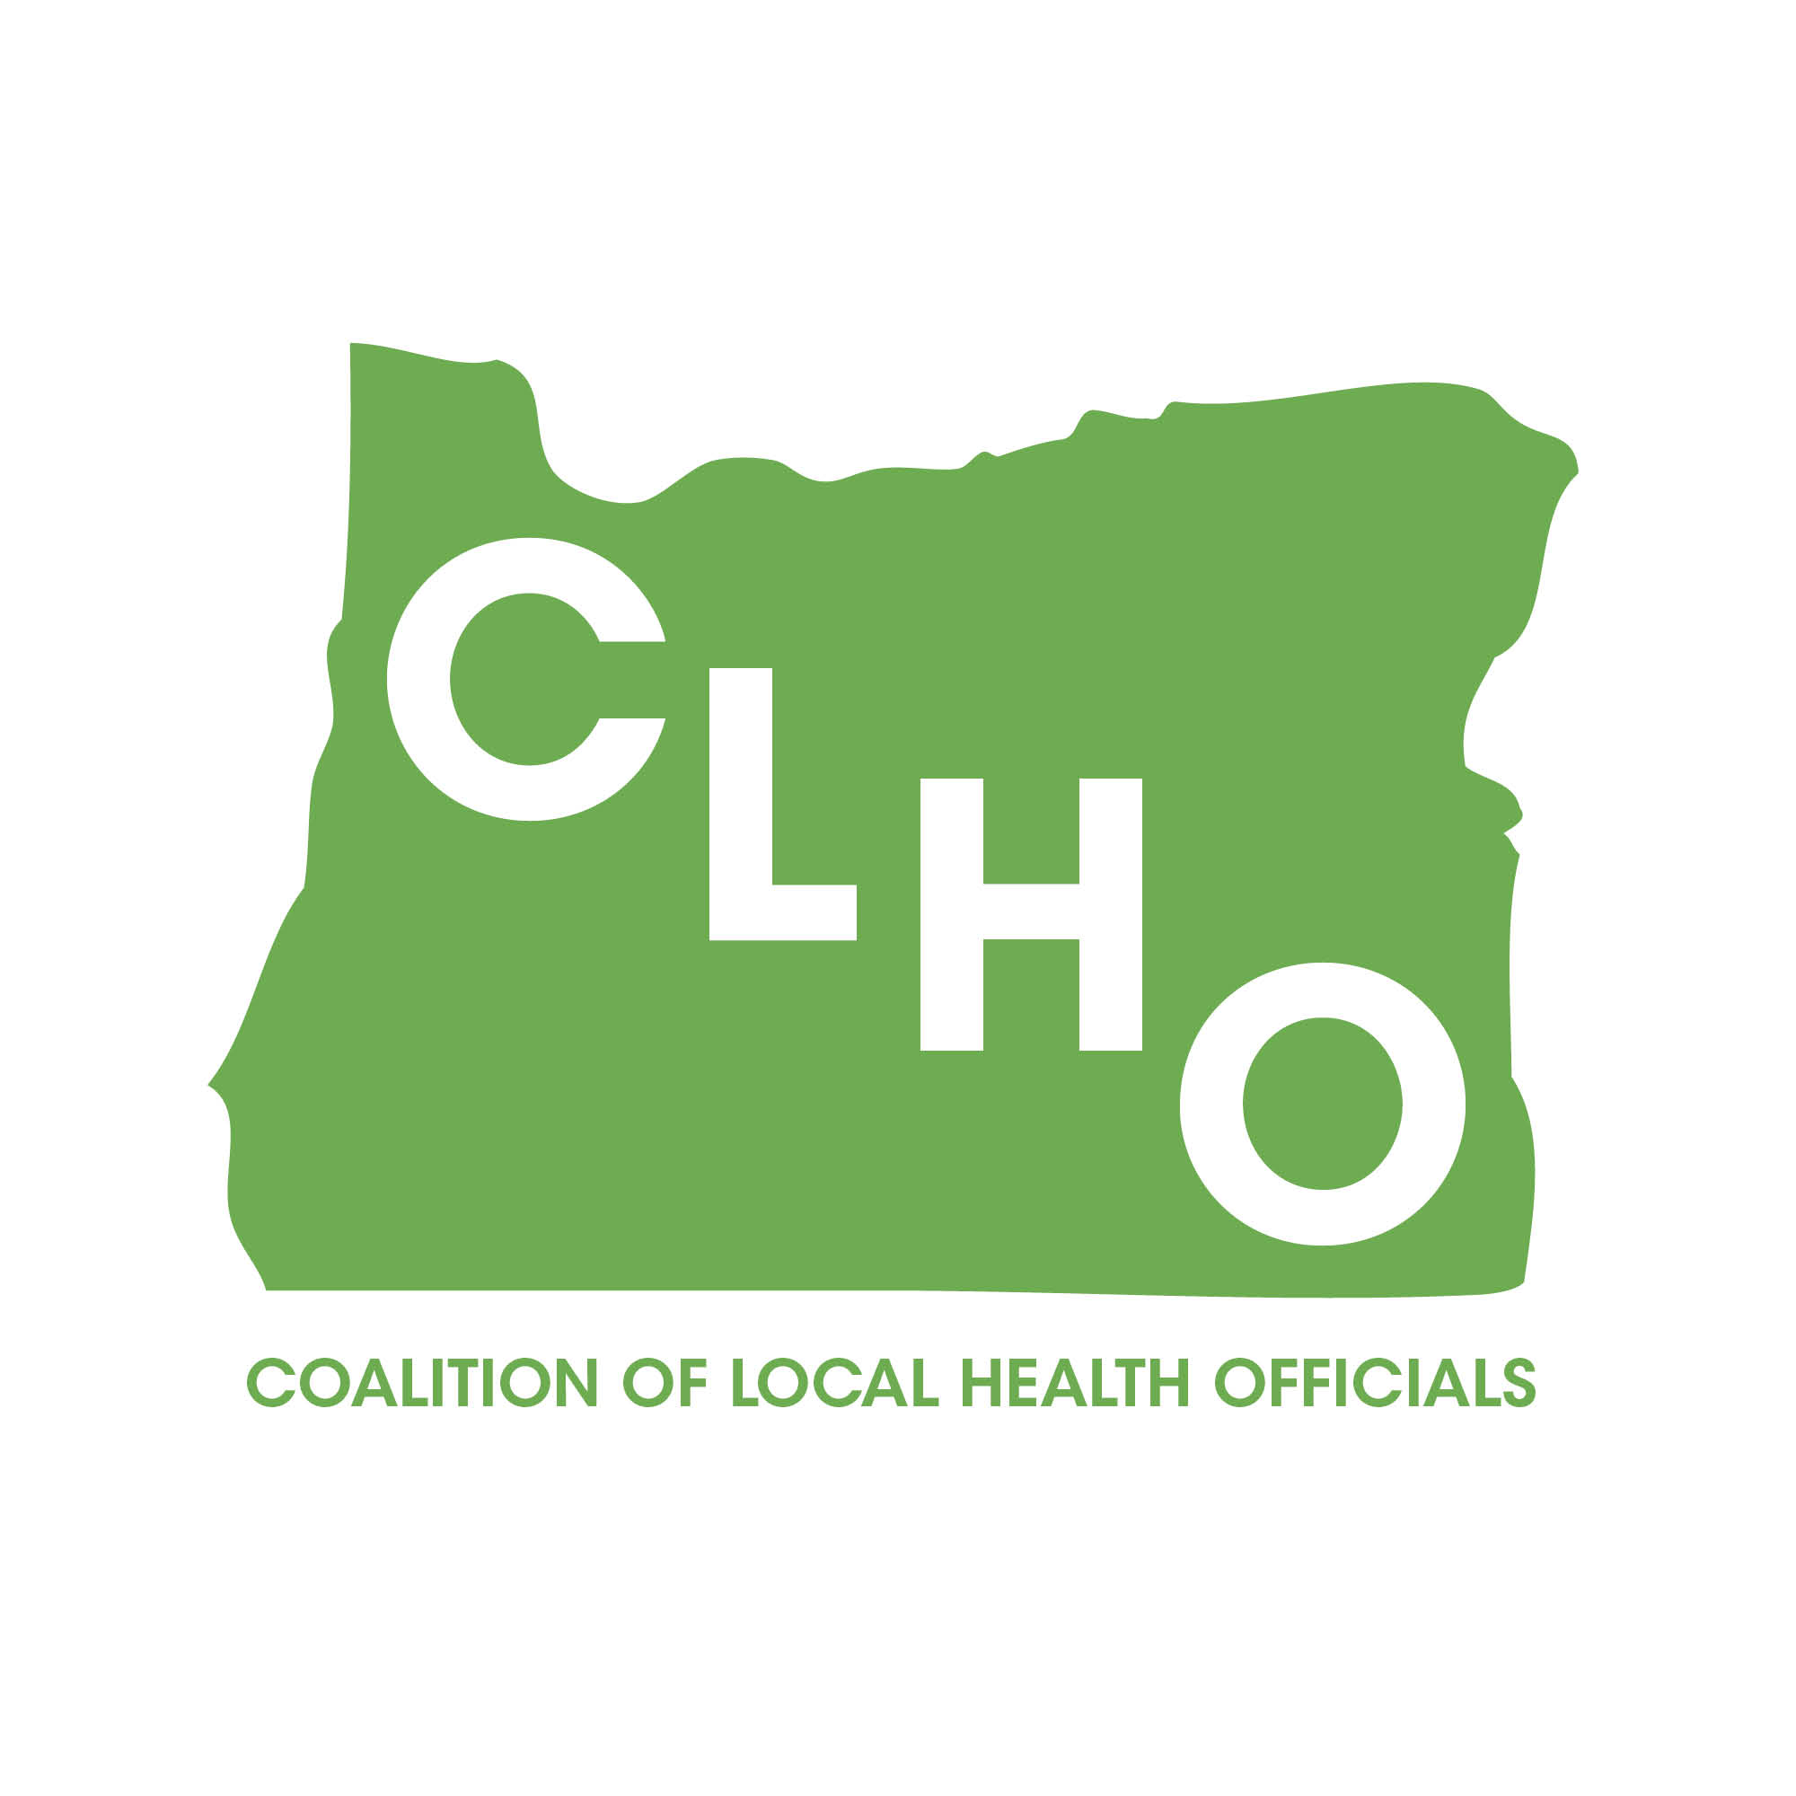 | CLHO Health Families Agenda  Portland State Office Building  ROOM 918  12:00-2:00 PM  March 18, 2015 | Join the meeting at:  https://www2.gotomeeting.com/join/862646250  Join the conference call:  1-888-273-3658  Participant code: 256313  Meeting ID: 862-646-250
CoChairs: Lindsey Manfrin | 503-846-3712 manfrinl@co.yamill.or.us
Judy Cleave | 503-361-2693 jcleave@co.marion.or.us

MINUTES
Agenda Item | Detail | Action Item | Responsible Party
Welcome & Introductions  (5 Minutes) |  | NA | NA
Review meeting minutes from1.21.15  (5 Minutes) | Brief review of meeting minutes | Approved by consensus. No action required. | NA
SBHC Update  (20 Minutes) | - Program Element Changes  Certification requirements in Statute now.  Added language for mental health grants.  No major changes this year, minor language changes, date changes added language for mental health grants.  - Expansion Grants  Possibility of more funding for planning and expansion grants. Would do competitive RFPs for both 2 year and advanced phase planning grant per the process in the current PE. A memo will be sent out notifying that this money may be coming in July. New counties will be prioritized. The State is working to develop a data sheet needed for counties who plan to apply.  - Mental Health Grants  Last year funding was released to expand MH services in SBHC. Will rerelease an RFQ for funding if comes through this year. Prioritize counties that didn’t get funding last time but also want to keep funding for existing places so disruptions are not made. May be able to release prior to end of legislative session in hopes of not having service gaps.  - Teen Pregnancy Prevention Program Grants  Overall rates are low in Oregon but certain areas have significantly higher rates in the state. The State is applying for programmatic funding for high risk counties as well as pay for the State’s Adolescent Sexuality position. Don’t have final approval from legislature yet. |  | Jessica Duke
PE 41 Proposed Changes (15 Minutes) | Proposed changes are minor—mostly updating language, reiterating what has always been an expectation or related to the subcontracting process. Reproductive Health Advisory Panel has already reviewed the changes.  Changes include:  Language regarding Reproductive Health protocols that have been created that LHD can adopt of modify and have approved by State.  Strengthened language that we have expectations of coordinators such as they need to attend annual meetings. Reiterate that coordinators are a liaison.  Removed 10% cap for income.  Added 10% maximum amount of funding to be withheld if subcontracting. | Changes approved  Will get on April Big CLHO meeting- Lindsey | Helene Rimberg
Suicide Prevention Update (15 Minutes) | State received Garrett Lee Smith Grant dollars.  5 year grant. 736, 000 per year. Ends in Sept 2019. Funding for 4 counties- Deschutes, Jackson, Josephine, Washington- will pick up three counties later in the grant to be funded for three years.  new programs.  See handout  State wide child fatality review team- meets twice per year. Multidisciplinary team. Use stories to find ways to prevent in the future and identify if there systems that fell short. Donna is a resource for counties If you want a specific case reviewed you can ask for it. Locals will be invited to attend. |  | Donna Noonan
Overview of how State Public Health tracks legislative bills  (15 Minutes) | Molly Emmons will discuss identification of legislative bills related to health and then the bill tracking.  See handout  Reviewed over 400 bills, 66 analysis.  Priority 3- track no analysis- most are  Priority 2- do formal analysis  Priority 1- analyze and think may need to do testimony.  School nurse position being proposed in legislation- not sure where they would be in the OHA system. Possibly within SBHC program |  | Molly Emmons
PE 42 Review/Approval | Minor changes made by DOJ. | Changes approved from DOJ. Will go to Big CLHO tomorrow. | Cate Wilcox
Title V funds and priorities (15 Minutes) | 3 supporting documents: Visual of the Block Grant prioritization and planning process; table of the recommendations for Title V priorities that emerged from the MCH Stakeholder meetings on Feb 17 and March 5); list of MCH Stakeholder meeting participants)  See Handouts  Needs assessment completed this winter, used as base to set block grant priorities that will start next October.  Feds require the State can pick 8 out of 15 priorities area. The selection was completed at first stakeholder meeting.  The 2nd stakeholder meeting was focused on picking 3-5 state specific priorities on current or emerging needs. The needs assessment was used to help set.  In August will work on strategies for each priority areas.  Identified Priority Areas:  Well women care  Breastfeeding  Physical activity  Adolescent well visit  Medical home and transition for children with special medical needs  Oral health- access and preventative service for kids and pregnant women  Smoking- tobacco or other things? believe it is smoking tobacco as marijuana not legalized federally.  Current or emerging State priorities -  Toxic stress and trauma- strong  Nutrition and food insecurity- strong  Culturally linguistic responsive services- aligns so strongly with equity focus  Starting in October we will begin a transition year. States plan is to have work groups in the fall to determine the menu of strategies and activities that we can engage in. Funding needs to move starting Jan 2016. Title v funds stay where they are first half of fiscal year starting January need to shift to the new Title V priorities and new activities need to be in place by March. Jan-March can use for workforce development.  Currently 34% of State title v funds goes to title x then goes to counties through title x. Title V dollars no longer going to title x so there will be a reduction in title x award with this change. It will reflect as an increase in title v awards.  Title v funding may look different and support different activities than what currently supports and how locals can use it based on the new Title V priorities.  Want local health departments involved in strategies for these and figuring out the work together  Next steps- strategies and measurements | Keep Title V work as a standing agenda item for the next several months.  Cate will be sending communication about the funding changes.  Will send federal guidance via email- Cate or Nurit | Cate Wilcox  Nurit Fischler
Oral Health Grant Update (10 Minutes) | Submitted a HRSA grant for perinatal and infant oral health- systems grant- focus areas:  - collaborate with CCOs to establish organizational policies and the provision of dental services and risk assessments during prenatal visits  - Continuation of first tooth model  - Collaboration around referral and coordination of these services  Another HRSA workforce development grant will be submitted. Have already received two workforce grants. It will builds on this completed work for underserved populations. Examples are: OHSU dental students rotations in rural areas and expanding current dental sealant program. It is a 3 year 1.5 million dollar grant. |  | Cate Wilcox
LAUNCH Grant Update (10 Minutes) | 5 Counties have been targeted for interest in applying for a 3 county expansion grant. It is only open to places who had a LAUNCH grant previously.  Goal is to decrease racial and ethnic disparities.  Data that shows Latina women and children don’t access mental health as often as others. They have become the target population The eligible counties were identified as having the highest % of Hispanics and were invited to put in a LOI to be part of grant application. 3 will be accepted. Ideas for funding include:  Expanding and using PCIT  Implementing maternal metal health work  Mental health consultation to home visiting and child care ECBPIS  Creating communities of practice  PH, primary care and behavioral health integration |  | Beth Gebstadt
Minutes) | Bob retiring June 1st  Molly retiring April 30th |  | Jessica Guernsey
Acronyms:

CLHO HEALTHY FAMILIES COMMITTEE
ATTENDANCE ROSTER
(March 18, 2015)

State Reps |  | Interested Parties |  | Interested Parties:
Bob Nystrom |  | Adrienne Greene |  | Renee Hackenmiller-Paradis
Cate Wilcox | X | Anna Stiefvater | X | Rebecca Strickler
Susan Woodbury |  | Benjamin Hazelton |  | Robin Stanton
 |  | Beth Gebstadt |  | Ronit Zusman
Local Reps |  | Caroline Neunzert | X | Rosalyn Liu | X
Arielle LeVeaux |  | Carrie Brogotti |  | Ruth Harshfield
Cathy Perry | x | Cheryl Alto |  | Terra Frenken
Chelsea Whitney |  | Cynthia Ikata |  | Traci Smith-McCarthy
David Brown |  | Dana Hargunani |  | Sheila Johnson | X
Dawnelle Marshall |  | Dianna Pickett | X | Terra Franklin | X
Holly Strahm |  | Francine Goodrich |  | Makia | X
Jessica Guernsey |  | Helene Rimberg | X
Judy Cleave | X | Isabelle Barbour
Kathy Devoss |  | Jackie Harris
Lindsey Manfrin | X | Jan Kaplan
Natalie Jones |  | Jennifer Young
Norma O’Mara | X | Jessica Duke
Pamela Ferguson | X | Kathy Christiansen | X
Shelly Paeth | x | Lari Peterson | X
Susan Pinnock | x | Lesa Dixon Gray
Teri Thalhofer |  | Marilyn Hartzell | X
 |  | Martha Baird | X
 |  | Molly Emmons
 |  | Morgan Cowling
 |  | Nurit Fischler | X
 |  | Rebecca Pollock

