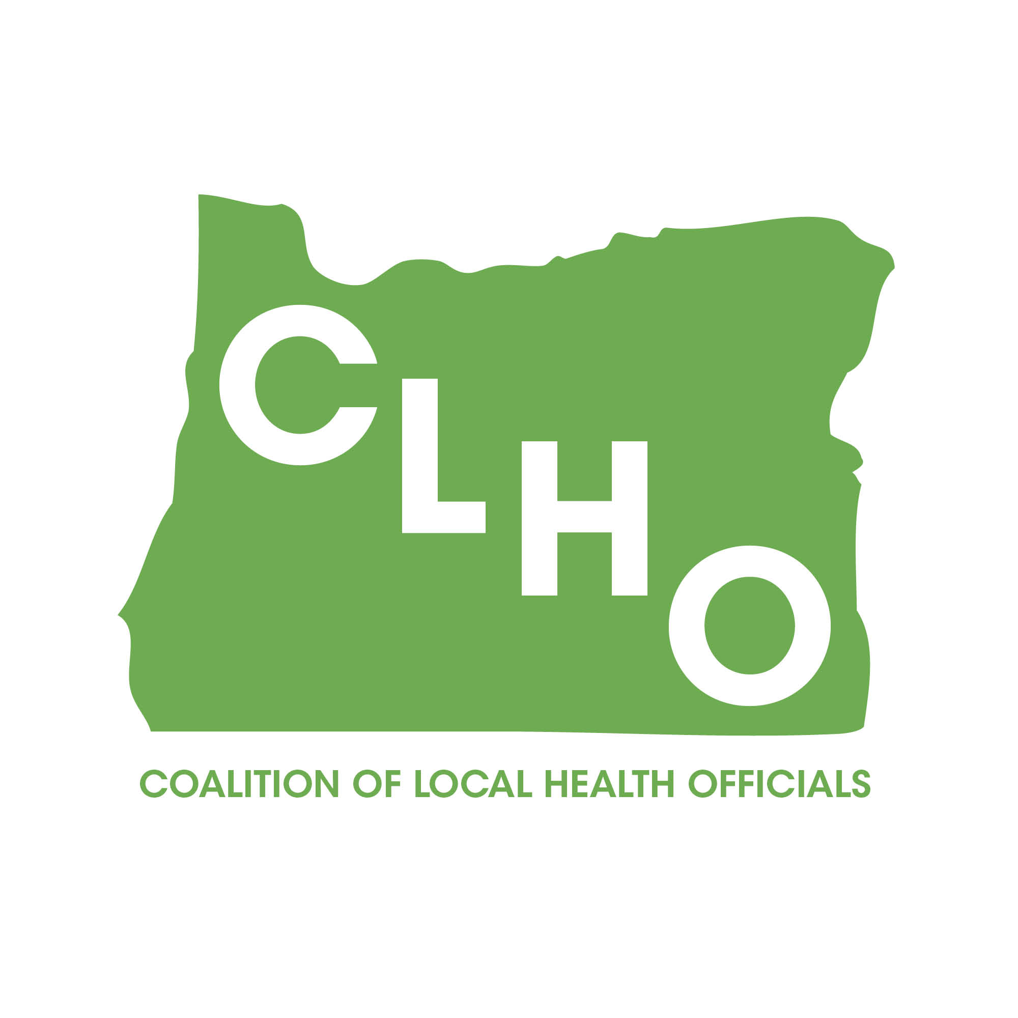 | CLHO Health Families Agenda  Portland State Office Building  ROOM 918  12:00-2:00 PM  March 18, 2015 | Join the meeting at:  https://www2.gotomeeting.com/join/862646250  Join the conference call:  1-888-273-3658  Participant code: 256313  Meeting ID: 862-646-250
CoChairs: Lindsey Manfrin | 503-846-3712 manfrinl@co.yamill.or.us
Judy Cleave | 503-361-2693 jcleave@co.marion.or.us

MINUTES
Agenda Item | Detail | Action Item | Responsible Party
Welcome & Introductions  (5 Minutes) |  | NA | NA
Review meeting minutes from1.21.15  (5 Minutes) | Brief review of meeting minutes | Approved by consensus. No action required. | NA
SBHC Update  (20 Minutes) | - Possible Program Element Changes  - Mental Health Grants  - Expansion Grants |  | Jesica Dike
PE 41 Proposed Changes (15 Minutes) | Proposed changes are minor—mostly updating language, reiterating what has always been an expectation or related to the subcontracting process. Provider advisory panel has already reviewed the changes. Need CLHO Healthy Families to review and approve. |  | Helene Rimberg
Suicide Prevention Update (15 Minutes) | State received Garrett Lee Smith Grant dollars. |  | Donna Noonan
Overview of how State Public Health tracks legislative bills  (15 Minutes) | Molly Emmons will discuss identification of legislative bills related to health and then the bill tracking. |  | Molly Emmons
PE 42 Review/Approval | Review, discussion, and approval to move forward to CLHO for final discussion/approval |  | Cate Wilcox
Title V funds and priorities (15 Minutes) | Cate will lay out what changes we need to anticipate with how the Title V funds will come to the counties during this upcoming transition year, vis-à-vis the changes to Title V priorities. (3 supporting documents: Visual of the Block Grant prioritization and planning process; table of the recommendations for Title V priorities that emerged from the MCH Stakeholder meetings on Feb 17 and March 5); list of MCH Stakeholder meeting participants) |  | Cate Wilcox  Nurit Fischler
Oral Health Grant Update (10 Minutes) |  |  | Cate Wilcox
LAUNCH Grant Update (10 Minutes) | 5 Counties Targeted for interest in applying for 3 county expansion beyond Deschutes and Multnomah Counties. |  | Beth Gebstadt
Multnomah County Grant Updates (10 Minutes) |  |  | Jessica Guernsey
Acronyms:

CLHO HEALTHY FAMILIES COMMITTEE
ATTENDANCE ROSTER
(Date)

State Reps |  | Interested Parties |  | Interested Parties:
Bob Nystrom |  | Adrienne Greene |  | Renee Hackenmiller-Paradis
Cate Wilcox |  | Anna Stiefvater |  | Rebecca Strickler
Susan Woodbury |  | Benjamin Hazelton |  | Robin Stanton
 |  | Beth Gebstadt |  | Ronit Zusman
Local Reps |  | Caroline Neunzert |  | Rosalyn Liu
Arielle LeVeaux |  | Carrie Brogotti |  | Ruth Harshfield
Cathy Perry |  | Cheryl Alto |  | Terra Frenken
Chelsea Whitney |  | Cynthia Ikata |  | Traci Smith-McCarthy
David Brown |  | Dana Hargunani
Dawnelle Marshall |  | Dianna Pickett
Holly Strahm |  | Francine Goodrich
Jessica Guernsey |  | Helene Rimberg
Judy Cleave |  | Isabelle Barbour
Kathy Devoss |  | Jackie Harris
Lindsey Manfrin |  | Jan Kaplan
Natalie Jones |  | Jennifer Young
Norma O’Mara |  | Jessica Duke
Pamela Ferguson |  | Kathy Christiansen
Shelly Paeth |  | Lari Peterson
Susan Pinnock |  | Lesa Dixon Gray
Teri Thalhofer |  | Marilyn Hartzell
 |  | Martha Baird
 |  | Molly Emmons
 |  | Morgan Cowling
 |  | Nurit Fischler
 |  | Rebecca Pollock

