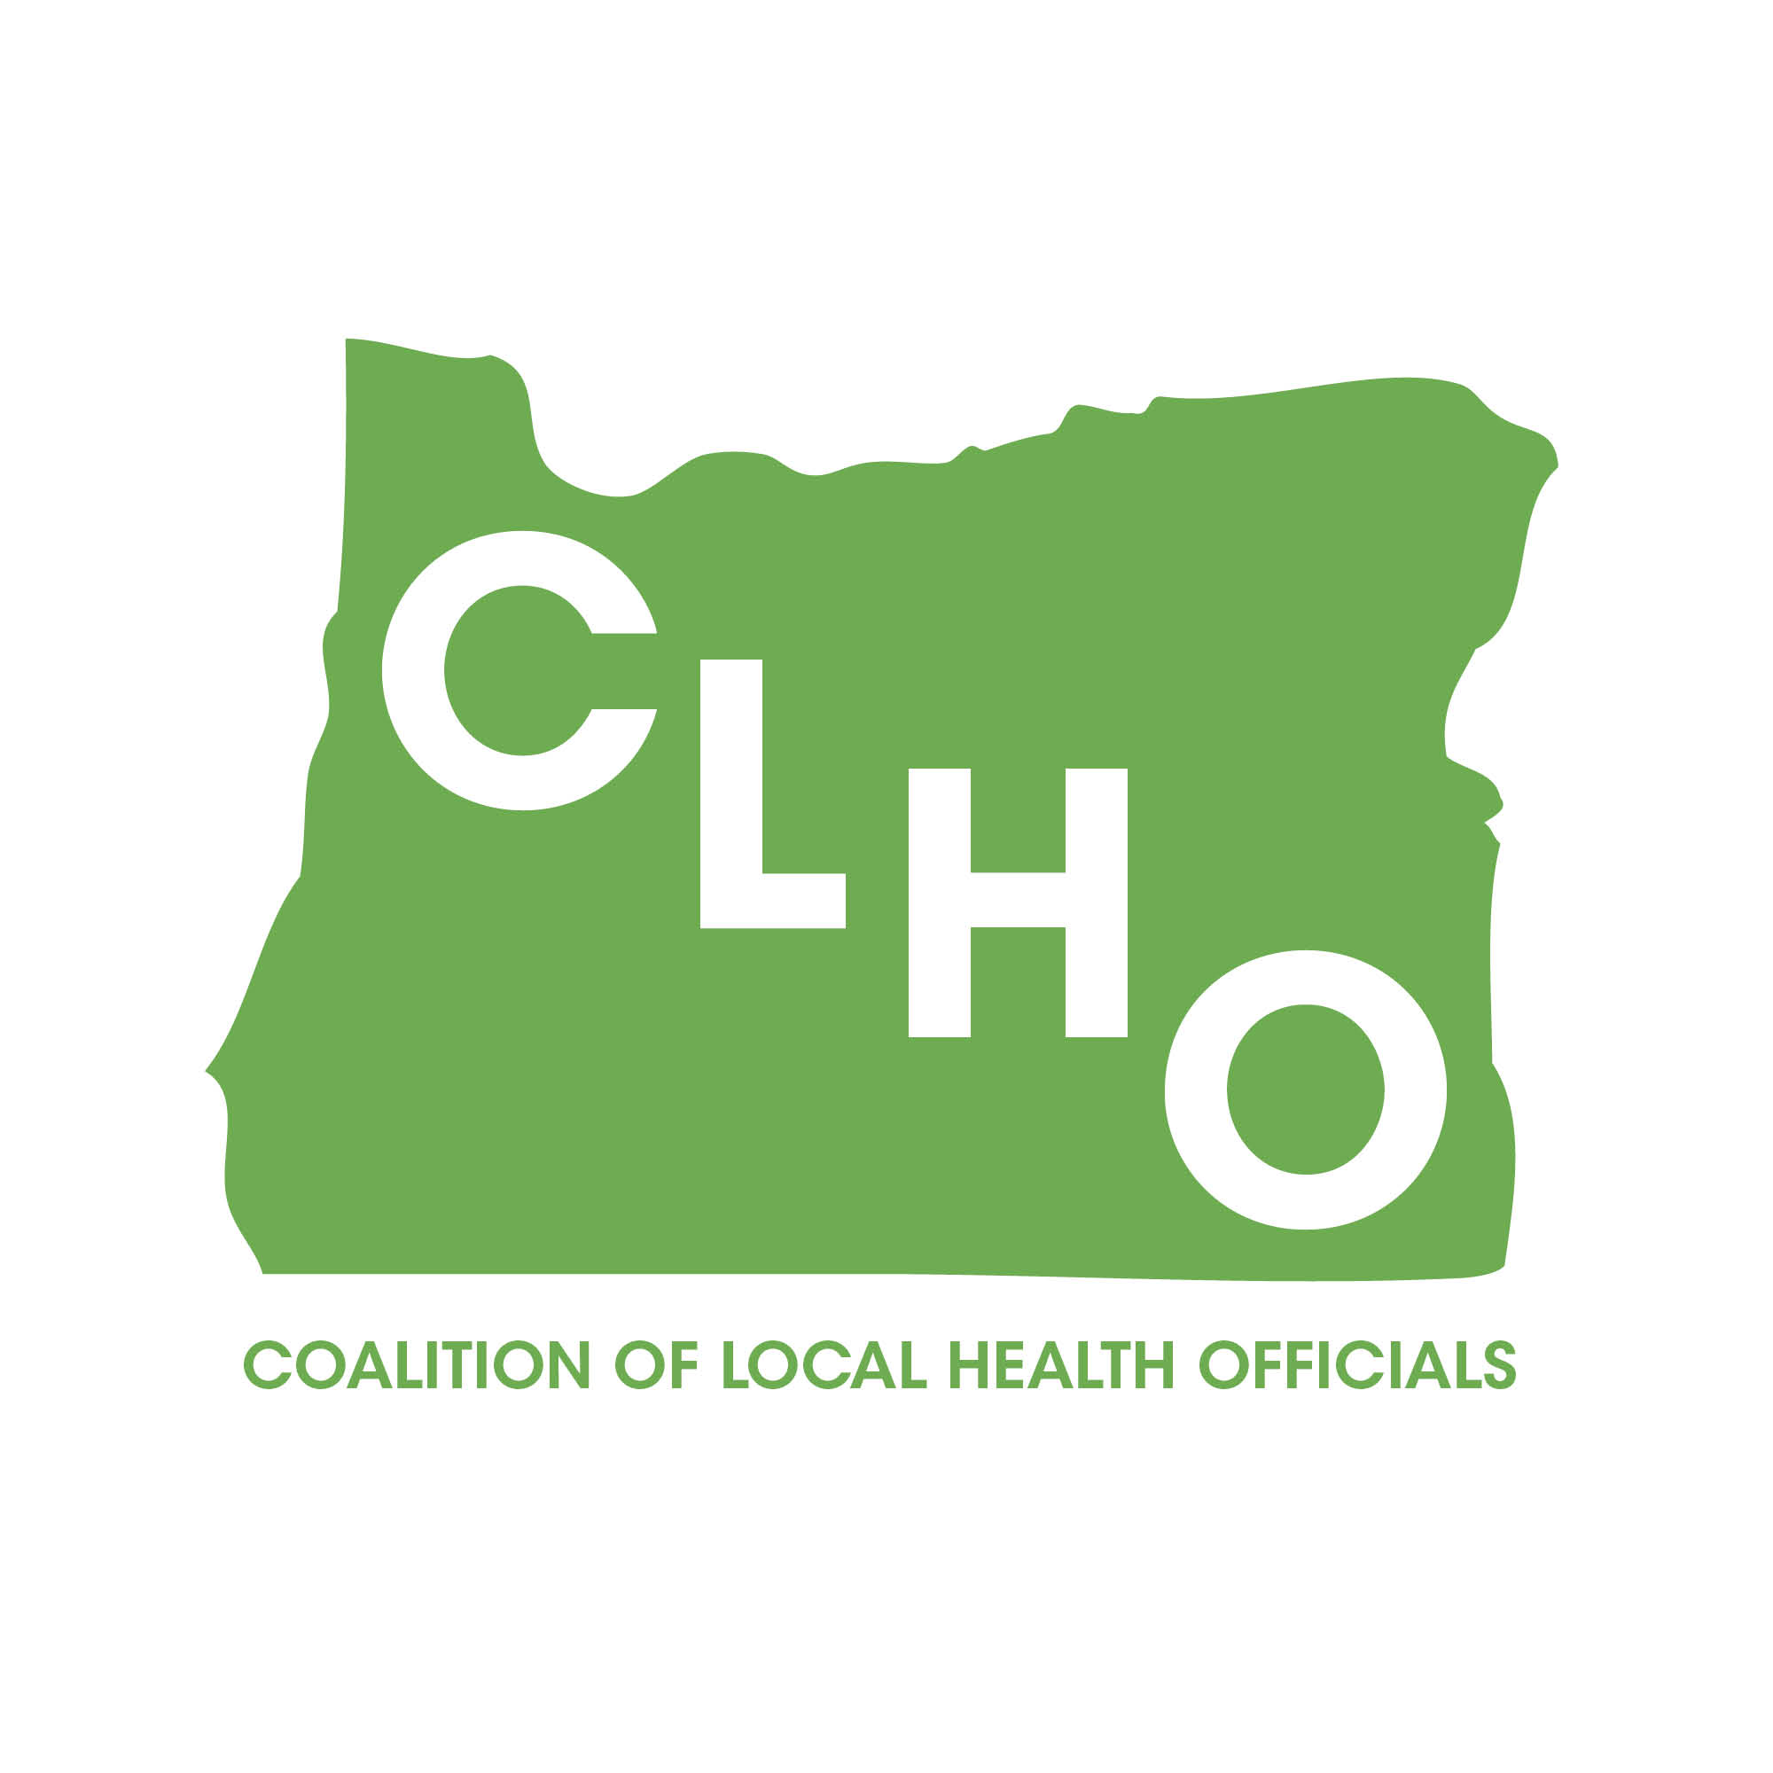 | CLHO Health Families Minutes  Portland State Office Building  ROOM 918  12:00-2:00 PM  January 21, 2015 | Join the meeting at:  https://www2.gotomeeting.com/join/651907194  Join the conference call:  1-888-273-3658  Participant code: 256313  Meeting ID: 651-907-194
CoChairs: Lindsey Manfrin | 503-846-3712 manfrinl@co.yamill.or.us
Judy Cleave | 503-361-2693 jcleave@co.marion.or.us

MINUTES
Agenda Item | Detail | Action Item | Responsible Party
Welcome & Introductions |  | NA | NA
Review meeting minutes from xxx  10min | Brief review of meeting minutes | Approved by consensus. No action required. | NA
TCM/County Leveraged health Programs & CCO Contract Update  15 min  Morgan Cowling/ Cate Wilcox | Template is supposed to be posted today (1/21) rather than being posted last Friday. FAQ’s from pre-CCO summit to be posted as well. Documentation Committee’s document is posted there, too. Budget numbers are due end of month. Contract template work group had hoped to finish its work by last Thursday, but plan now to finish by end of January. Will have template for statement of work and for compensation piece. Used existing language that will be familiar to users. Language is not complicated. One discussion point was about DMAP’s plan to address program growth. This is a point of angst. Don does not think the TCM monies and planned growth will have a huge impact on the DMAP budget; however, growth amount is not guaranteed. Morgan asked for feedback and questions. | None Needed
Home Visiting Database Update  5 min  Lari Peterson | Still working to refine data points. Roll out will start with MCIECHV Cate reminded people that MCM will be a part of the global budget for CCOs. As we develop contracts with CCOs need to include MCM in global budget contract. Open card clients will be through DMAP, but all enrolled clients will be tied into the global budget. Title V question posed by Washington County. For budgets coming forward need to use existing funding formulas. We will not be able to be as flexible as we were when the Title V budget cuts came last time.
Revision of charter  25 min  All | Committee reviewed Goals & Objectives on pages 7 & 8. Recommendations made. Will invite Molly Emmons to report at February meeting.
Adverse Childhood Experiences (ACES) 15min  Beth Gebstadt | ACES has been developed over the past 15 years. 11 questions were added to BRFSS in 2011. Report was developed. Have developed Statewide reports, but not County level yet. 2011-2013 report will be sent out by Cate after this meeting. Trauma informed care is a part of this. Trauma Informed Oregon (TIO) website has a lot of good information. See:  http://traumainformedoregon.org/
PE 42 Draft Revisions  20 min  Cate | Committee presented recommended changes with the plan that in a year another round of revisions would be made. After our review and recommendation DOJ will need to review the document and may make additional changes. Most of the changes are modest and meant to increase clarity of the document. Document will be reviewed in a year and revised according to developing changes.CLHO Healty Families recommends moving draft on to DOJ and then to full CLHO meeting for discussion and approval.
Breastfeeding  15 min  Susan Greathouse | Susan Greathouse presented. PCPs more comfortable talking about breast pumps rather than breastfeeding. ACA language opened door to provision of lactation equipment. Began conversations with DMAP August 2014. WIC was invited to write language around breastfeeding supplies. Guidance was released in January. Breast pumps and supplies are covered under DMAP rules now to support breastfeeding up to 6 months post partum. Could develop agreement with CCOs to have breast feeding work by IBCLCs who are nurses. Language to be developed by WIC. WIC is trying to get out of being the first provider of breast pumps.
EDHI Referrals  15min  Heather Morrow Almeda | Heather Morrow Almeda presented. We receive two types of referrals: 1) Diagnosed hearing problems. 2) Tracking down infants who need hearing screening. Referrals come from regional nurses consultants. In February referrals will come from program staff, not regional nurse consultants. Email address would be from Oregon EHDI and subject line would be EHDI Referral. Information will be similar to currently shared information, but will be in a different format. State is looking for feedback from local health departments to assess how well EHDI is working. Information will be in body of email rather than as an attachment like it is now. Heather invites people to look at EHDI website. It includes an EHDI TED talk, national website for hearing screening training, information about Audiology 101 training. There is also a feedback mechanism on the website so parents or professionals can give feedback to EHDI. Heather has taken over the lead role for health in childcare since Dianna Pickett retired. |  | Cate/Heather
Items for next time:
- Annual Face to Face Meeting
- Suicide Prevention
- Multnomah County Grant Updates
- Molly Emmons legislative update

Acronyms:
CLHO HEALTHY FAMILIES COMMITTEE
ATTENDANCE ROSTER
January 21, 2015

State Reps |  | Interested Parties |  | Interested Parties:
Bob Nystrom |  | Adrienne Greene |  | Renee Hackenmiller-Paradis
Cate Wilcox | x | Anna Stiefvater | x | Rebecca Strickler
Susan Woodbury |  | Benjamin Hazelton |  | Robin Stanton
 |  | Beth Gebstadt |  | Ronit Zusman
Local Reps |  | Caroline Neunzert | x | Rosalyn Liu
Arielle LeVeaux |  | Carrie Brogotti |  | Ruth Harshfield
Cathy Perry | x | Cheryl Alto |  | Sheri Salber
Chelsea Whitney |  | Cynthia Ikata | x | Terra Frenken
David Brown | x | Dana Hargunani |  | Traci Smith-McCarthy
Dawnelle Marshall |  | Dianna Pickett
Holly Strahm |  | Francine Goodrich
Jessica Guernsey | x | Helene Rimberg
Judy Cleave | x | Isabelle Barbour
Kathy Devoss | x | Jackie Harris
Lindsey Manfrin | x | Jan Kaplan
Natalie Jones | x | Jennifer Young
Norma O’Mara | x | Jessica Duke
Pamela Ferguson | x | Kathy Christiansen
Shelly Paeth | x | Lari Peterson | x
Susan Pinnock | x | Lesa Dixon Gray
Teri Thalhofer | x | Marilyn Hartzell
 |  | Martha Baird | x
 |  | Molly Emmons
 |  | Morgan Cowling | x
 |  | Nurit Fischler
 |  | Rebecca Pollock

