**CLHO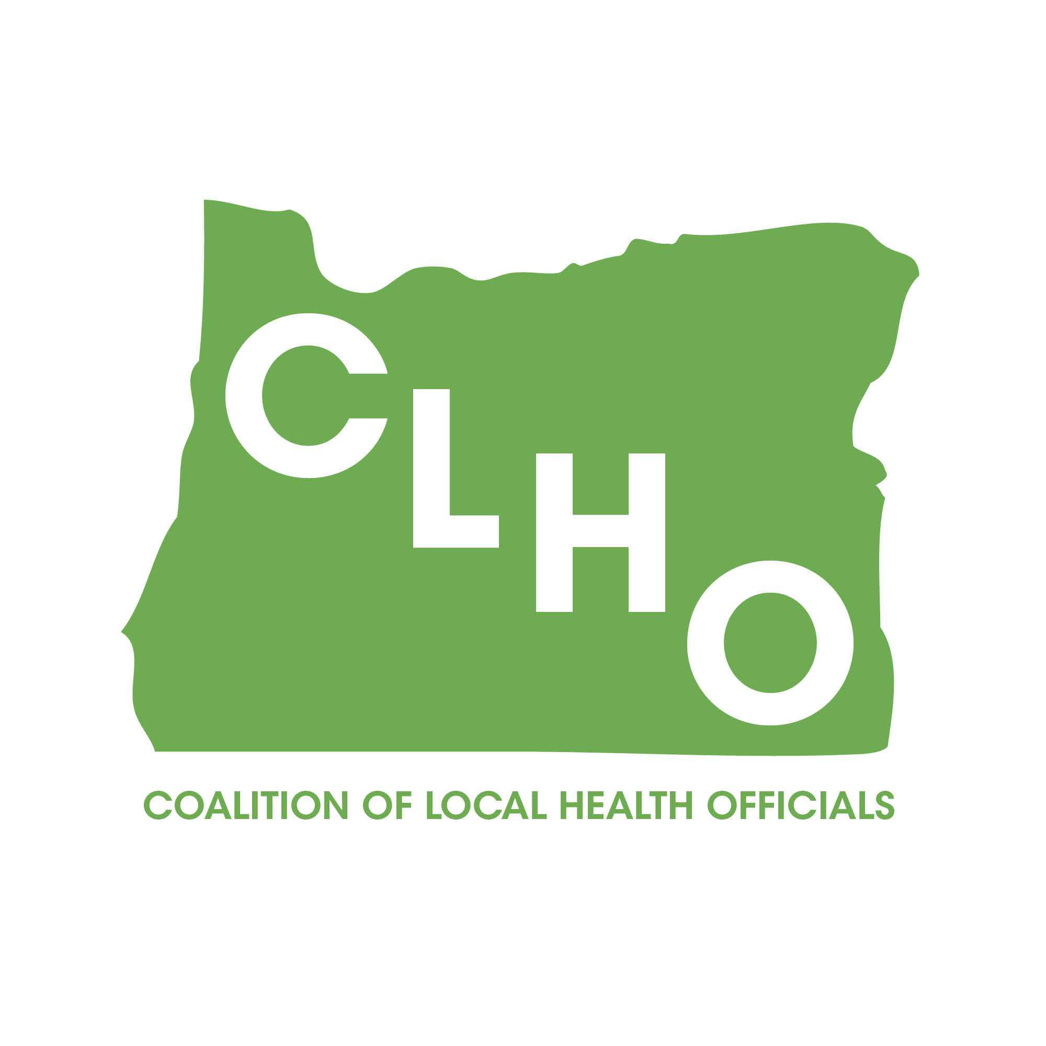CLHOCLHO**

|  |  |
| --- | --- |
| **Document name** | **Title CLHO Healthy Families Committee Charter** |
| Category | ( ) Regional Reliability Standard  ( ) Regional Criteria  ( ) Policy  ( ) Guideline  ( ) Report or other  (X) Charter |
| Document date |  |
| Adopted/approved by |  |
| Date adopted/approved |  |
| Custodian (entity responsible for maintenance and upkeep) |  |
| Stored/filed | Physical location:  Web URL: |
| Previous name/number | (if any) |
| Status | ( ) in effect  ( ) usable, minor formatting/editing required  ( ) modification needed  ( ) superseded by _____________________  ( ) other _____________________________  ( ) obsolete/archived |



**CLHO HEALTHY FAMILIES COMMITTEE** CHARTER

Revised May 17, 2013

###### Establishment and Authority

The Conference of Local Health Officials (CLHO) Healthy Families Committee is a member (e.g., member or Board) committee established by the CLHO By-Laws and the current CLHO Chair.

###### Purpose/Responsibilities

The purpose of the CLHO Healthy Families Committee is to provide maternal, child and adolescent health expertise from local health departments in partnership with the Oregon Health Authority MCAH programs to benefit Conference operation.

The CLHO Healthy Families Committee shall:

1. Make recommendations to the Conference Executive Committee and Board on policy, financing, and other major programmatic changes.
2. Submit recommendations to change funding formulas to the CLHO Healthy Structure Committee and Program Element recommendations directly to CLHO.
3. Provide a forum for local and State health department professionals to share relevant data, assessments, funding opportunities, and other related information that will inform Oregon’s system of public health focused on maternal and child health.
4. Present annually to the Conference Board a current status report, including membership, identification of future issues and a strategic plan to address those issues.
5. Perform such other functions as may be delegated by the Conference and its current Chair.

##### Committee Composition and Governance

1. ***Membership***
2. The CLHO Healthy Families Committee shall be comprised of local health department administrators and public health managers with MCAH expertise and designated Public Health Division (PHD) partners.
3. The Local Health Department members shall be appointed annually by the Conference Chair. Any interested person may request to be a committee member.
4. The State Committee members are appointed by the Public Health Division Director.
5. Local Health Department members are voting members. State Committee members are not voting members.
6. Local members shall serve terms of a one year minimum.
7. Local and State Committee members agree to fulfill essential job function (EJF) for their membership through review and signature of the EJF. (Addendums E and F)
8. ***Leadership***
9. The chair of the Conference of Local Health Officials shall appoint Co-Chairs of the CLHO Healthy Families Committee.
10. The Co-Chairs shall manage the committee and its meetings as noted in the essential job functions attached (Addendum F).
11. ***Meetings***
12. The CLHO Healthy Families Committee shall determine the time and place of its meetings.
13. The CLHO Healthy Families Committee shall determine the procedures for its meetings.
14. A quorum for meetings shall be a simple majority.
15. Action taken by the CLHO Healthy Families Committee shall require a majority vote of those members present. However, the committee will always strive for consensus.
16. CLHO Healthy Families meetings may be in person or by webinar/conference call, as determined by the co-chairs.
17. The co-chairs shall provide email notice of the time and place of all meetings to each member of the CLHO Healthy Families Committee and to the Board, no later than two days prior to each meeting. An agenda of the items for which action may be taken shall be attached to the email notice. Any member of the Board may attend any meeting held in person and may monitor any meeting held by conference call. Supporting documents for agenda items will be provided no later than two days prior to each meeting.

Committee Approval System

The CLHO Healthy Families Committee will vote to approve most action items during meeting times. Since there are times when action items may arise outside of regularly scheduled meetings the co-chairs may share information and poll members by email for time sensitive action items. Approval will be by simple majority, although consensus will sought.

##### Reporting

The CLHO Healthy Families Committee shall report to the Conference Board on its activities and any recommendations.

##### Review and Changes to the Charter

The CLHO Healthy Families Committee shall review this charter on an annual basis and recommend any changes to the Conference Board and its current Chair.

**Approved by ________**

**CLHO Healthy Families Committee Charter**

**Addendum A**

**Planned Activities for 2014-15**

Members will participate on the Home Visiting Design Committee and various HV Design Subcommittees.

Members will participate on committees formed by the Oregon Center for Children and Youth with Special Health Needs and the Public Health Division Center for Prevention and Health Promotion.

Members will monitor the impact of statewide policy decisions on state and local MCAH and will make recommendations regarding implementation.

The CLHO Healthy Families Committee will strive to align current services, programs, and policy initiatives with the ongoing reform efforts of the Early Learning Division and the Coordinated Care organizations.

The CLHO Healthy Families Committee will advocate for maternal and child health populations and MCH prevention and health promotion efforts as part of health care transformation.

CLHO Healthy Families Committee will use data, evidence based practices, and other reports and studies to improve and support the understanding of public health and Maternal and Child Health sciences within ongoing reform efforts.

Members will work with State partners to develop a TCM/County Leveraged Healthcare Programs system that meets the needs of the State programs, the local providers of services, and the Coordinated Care Organizations.

The CLHO Healthy Families Committee will take an interest in topics of other committees that have cross-over impact with the programs listed in Addendum B.

**CLHO Healthy Families Committee Charter**

**Addendum B**

CLHO Healthy Families Committee includes the following Public Health Division Programs:

**Maternal, Child and Adolescent Health Section Manager Cate Wilcox**

* Child Health including “Babies First!”
* MCH Block Grant (Title V)
* Perinatal Health including Maternity Case Management (MCM) and Oregon MothersCare (OMC)
* Women’s Health
* Maternal, Infant, Early Childhood Home Visiting (MIECHV)
* Early Hearing Detection Intervention (EHDI)
* Oral Health
* PRAMS/PRAMS II
* MCH Epidemiology
* SID’s/SUID
* Preconception Health
* Birth Anomalies Registry
* Nurse Family Partnership (NFP)

**Nutrition and Health Screening Section Manager Susan Woodbury**

* WIC
* Breastfeeding Peer Counseling
* Farm Direct Nutrition Program

**Adolescent, Genetics and Reproductive Health Section**  **Manager Robert Nystrom**

* Adolescent Health
  + School Based Health Centers
  + Healthy Kids Learn Better (Coordinated School Health)
  + Youth Sexual Health-PREP (Personal Responsibility & Education Program)
* Reproductive Health
  + Title X (Family Planning and CCare)
  + Breast and Cervical Cancer Programs (BCCP)/WISEWOMAN
* Genetics

**CLHO Healthy Families Committee Charter**

**Addendum C**

**Goals and Objectives (2014/2015)**

* + 1. CLHO Healthy Families structure will be well defined and understood by all members.
    - Develop charter and garner approval from committee members and CLHO
    - Implement use of charter, including signed Essential Job Functions for members and co-chairs.
    1. Meetings will be well attended and more interactive.
* Continue use of GoToMeeting
* Implement proven strategies that increase distance meeting interaction such as use of a map that demonstrates where participants are located and indicates their names; asking specific participants for feedback by name; involving members in subcommittee work or asking them to be prepared to address a specific agenda item; provide CV with picture for each committee members to help members know more about each other. David Brown will update CVs, since membership is much different than it was initially.
* Implement plan for at least one face to face meeting annually.
  + 1. Participate in planned activities noted on page 5 of Addendum A.
* Track committee member involvement in HV System Design Committee and Subcommittees.
* Track CLHO Healthy Families committee member involvement in committees formed by the Oregon Center for Children and Youth with Special Health Care Needs and the Public Health Division Center for Prevention and Health Promotion.
* Assure that committee members utilize data, evidence based practices, and other reports and studies to improve and support the understanding of public health and Maternal, Child and Adolescent Health sciences within ongoing reform effort. This will be the standard for committee meetings and will be shared with all local health departments. Store this information in a common site for easy access by local health department members. At this time it appears that the CLHO Committee webpage for CLHO Healthy Families will meet this need.
* Provide legislative testimony to support state MCH programming bills following state and local health department policy and guidelines. Testimony will be tracked for annual report. We will engage Molly Emmons to see how we might develop a tracking mechanism.
* Track and document work to develop the new State TCM system for the annual report to CLHO.

**CLHO Healthy Families Committee Charter**

**Addendum D**

**Local Health Department Committee Member Essential Job Functions**

* Attend and prepare for meetings as scheduled.
* Volunteer for committee tasks to share the workload and promote timely completion of projects.
* Utilize the CLHO Committee structure to its full potential.
* Agree to participate for a minimum of one year.
* Notify the Committee Co-Chairs of intent to resign.
* Read and understand CLHO Healthy Families Committee Charter.
* Sign Essential Job Functions.

As a CLHO Healthy Families Committee member I agree to perform the above Essential Job Functions.

I agree to support the CLHO Healthy Families Committee Guiding Principals as noted below:

* Shared Vision and Purpose
* Commitment to Transparency
* Trust and Respect
* Clarity of Process
* Attitude that Supports a Shared Vision
* Leadership

I support the CLHO Healthy Families Committee **Vision for Success**:

State and Local CLHO Healthy Families members work together as a system with complementary and defined roles and standards. Planning and decision making is proactive, transparent, shared, and effectively communicated—leading to coordinated and sustainable Maternal, Child and Adolescent Health programs.

I understand that CLHO will provide:

* Strategic direction for CLHO Committees
* Determine the CLHO Committee structure
* Support committees with orientation and guidance.
* Address conflicts that interfere with optimal committee functioning.

Signature_____________________________________Date_____________________

**CLHO Charter**

**Addendum E**

**State Committee Member Essential Job Functions**

* Work with co-chairs to develop agendas.
* Attend CLHO Healthy Families Committee meetings.
* Bring Program Element proposed changes/revisions to the meetings for discussion and approval.
* Bring funding formula changes to Healthy Families Committee meetings for discussion and approval before moving to CLHO Health Structure Committee.
* Recruit Healthy Families Committee members to sit on program planning committees, or advisory boards.
* Orient new PHD staff to the role of the CLHO Healthy Families Committee.
* Coordinate data collection, analysis, and other relevant documents.
* Provide meeting space and technology support.

As a CLHO Healthy Families Committee member I agree to perform the above Essential Job Functions.

I agree to support the CLHO Healthy Families Committee Guiding Principals as noted below:

* Shared Vision and Purpose
* Commitment to Transparency
* Trust and Respect
* Clarity of Process
* Attitude that Supports a Shared Vision
* Leadership

I support the CLHO Healthy Families Committee **Vision for Success**:

State and Local CLHO Healthy Families members work together as a system with complementary and defined roles and standards. Planning and decision making is proactive, transparent, shared, and effectively communicated—leading to coordinated and sustainable Maternal, Child and Adolescent Health programs.

I understand that CLHO will provide:

* Strategic direction for CLHO Committees
* Determine the CLHO Committee structure
* Support committees with orientation and guidance.
* Address conflicts that interfere with optimal committee functioning.

Signature_____________________________________Date_____________________

**CLHO Charter**

**Addendum F**

**CLHO Healthy Families Committee Co-Chair Essential Job Functions**

* Plan future agendas with the PHD and committee members.
* Set meeting dates and create and send agendas that facilitate planning, availability of participants and timely preparation.
* Facilitate meetings.
* Draft correspondence and assure meeting minutes are prepared and communicated.
* Coordinate the timeframe for project completion.
* Notify CLHO of significant issues related to statutory/rule changes; and policy, funding or guideline changes.
* Present updates or requests for recommendation approval or guidance to CLHO with ten days prior notice.
* Serve as the primary contact for the Public Health Division-Center for Prevention and Health Promotion.
* Maintain current list of membership and request recruitment from CLHO when necessary.
* Present Annual Report to CLHO.

**Signature______________________________________________Date___________**