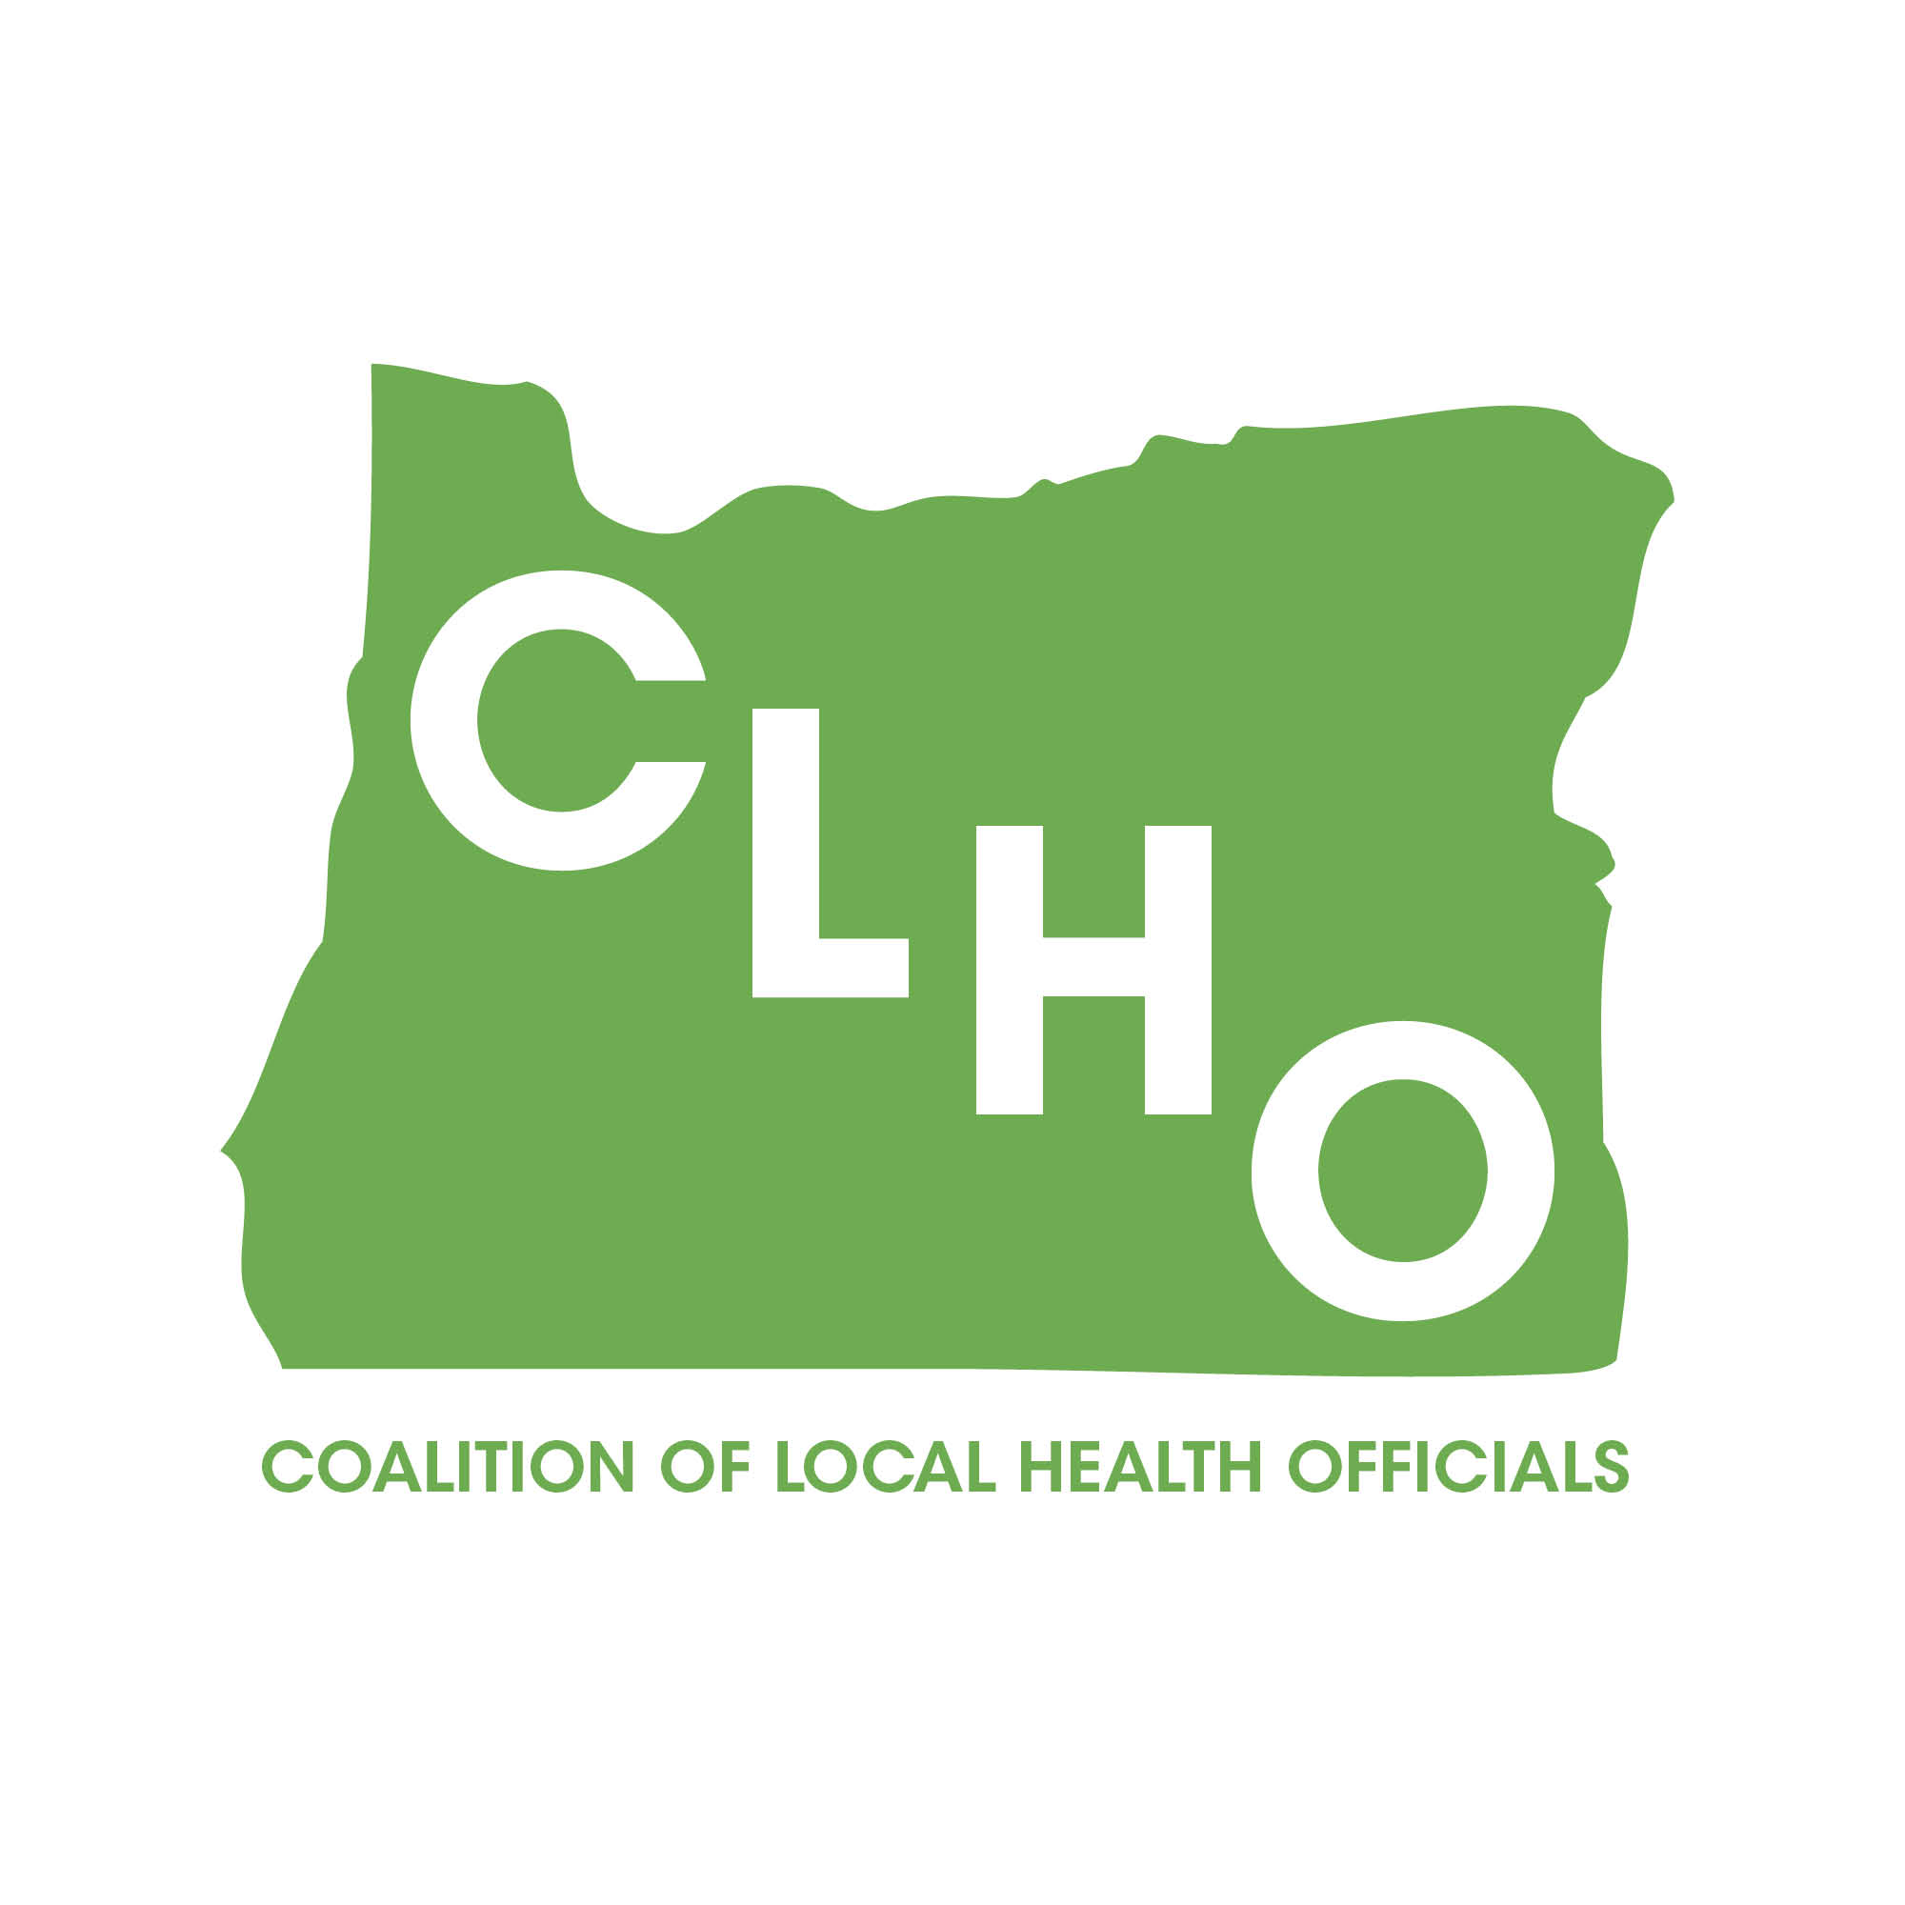 | CLHO Health Families Agenda  Portland State Office Building  ROOM 918  12:00-2:00 PM  August 19, 2015 | Join the meeting at:  https://www2.gotomeeting.com/join/473560210  Join the conference call:  1-888-273-3658  Participant code: 256313  Meeting ID: 473-560-210
CoChairs: Lindsey Manfrin | 503-846-3712 manfrinl@co.yamill.or.us
Judy Cleave | 503-361-2693 jcleave@co.marion.or.us

MINUTES
Agenda Item | Detail | Action Item | Responsible Party
Welcome & Introductions  12:00 – 12:05 PM |  | NA | NA
Review meeting minutes from July 15, 2015  12:05-12:10 PM | Brief review of meeting minutes | Approved by consensus. No action required. | NA
Home Visiting Data System Update  10 Minutes  12:10-12:20 PM |  |  | Lari Peterson
Staffing Update  10 Minutes  12:20-12:30 PM |  |  | Lari Peterson
Title V Update; Follow up on request for co-leads/steering committee members for strategy development on New Block Grant priorities  10 Minutes  12:30-12:40 |  |  | Nurit Fischler
WIC Update  10 Minutes  12:40-12:50 PM | Three topics of interest to local health departments will be discussed:  - Breastfeeding Bonus  - E-WIC Update  - Soy Formula Change |  | Sue Woodbury
Feedback for Modernization of Public Health  15 Minutes  12:50 PM-1:05 PM | Kathleen requests feedback on the Prevention and Health Promotion and Access to Clinical foundational programs. |  | Kathleen Johnson
SBHC Certification Review  10 Minutes  1:05-1:15 PM |  |  | Rosalyn Liu
CLHO Healthy Families Charter/Annual Plan Review  10 Minutes  1:15-1:25 PM |  |  | All
Acronyms:
CLHO HEALTHY FAMILIES COMMITTEE
ATTENDANCE ROSTER
August 19, 2015

State Reps |  | Interested Parties |  | Interested Parties:
Cate Wilcox | A | Adrienne Greene |  | Rebecca Pollock
Susan Woodbury |  | Anna Stiefvater |  | Renee Hackenmiller-Paradis
 |  | Benjamin Hazelton |  | Rebecca Strickler
 |  | Beth Gebstadt |  | Robin Stanton
Local Reps |  | Caroline Neunzert |  | Ronit Zusman
Arielle LeVeaux |  | Carrie Brogotti |  | Rosalyn Liu
Cathy Perry |  | Cathy Cooley |  | Ruth Harshfield
 |  | Cheryl Alto |  | Terra Frenken
 |  | Cynthia Ikata
Dawnelle Marshall |  | Dana Hargunani
Holly Strahm |  | Dianna Pickett
Jessica Guernsey |  | Francine Goodrich
Judy Cleave |  | Helene Rimberg
 |  | Isabelle Barbour
Lindsey Manfrin |  | Jackie Harris
 |  | Jan Kaplan
Norma O’Mara |  | Jennifer Young
Pamela Ferguson |  | Jessica Duke
Shelly Paeth |  | Kathy Christiansen
Susan Pinnock |  | Lari Peterson
Teri Thalhofer |  | Lesa Dixon Gray
 |  | Marilyn Hartzell
 |  | Marti Baird
 |  | Molly Emmons
 |  | Morgan Cowling
 |  | Nurit Fischler

