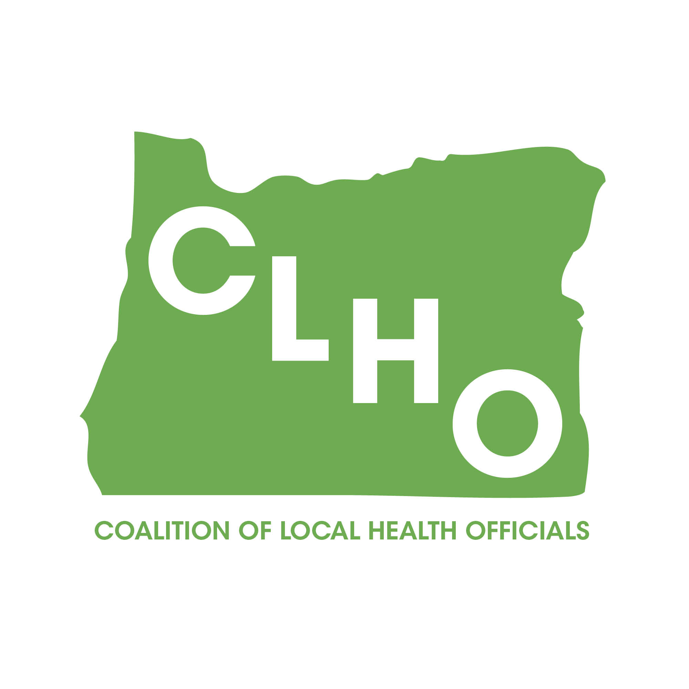 | CLHO Health Families Agenda  Portland State Office Building  ROOM 918  12:00-3:00 PM  April 15, 2015 | Join the meeting at:  https://www2.gotomeeting.com/join/651907194  Join the conference call:  1-888-273-3658  Participant code: 256313  Meeting ID: 651-907-194
CoChairs: Lindsey Manfrin | 503-846-3712 manfrinl@co.yamill.or.us
Judy Cleave | 503-361-2693 jcleave@co.marion.or.us

MINUTES
Agenda Item | Detail | Action Item | Responsible Party
Welcome & Introductions |  | NA | NA
Review meeting minutes from xxx  5min | Brief review of meeting minutes | Approved by consensus. No action required. | NA
SBHC Key Performance Measures  12:05-12:25(15 min) |  |  | Kate O’Donnell
TCM/County Leveraged Health Programs/MCM update 12:25-12:40 (15 min) |  |  | Lindsey/Morgan
Title V Changes  12:40-1:00 (20 min) |  |  | Nurit/Cate
Home Visitor Workforce Development Plan 1:00-2:00 (1hr) |  |  | Cynthia Ikata & Robin Hill-Dunbar
Items for next time:

Acronyms:
CLHO HEALTHY FAMILIES COMMITTEE
ATTENDANCE ROSTER
April 1e5, 2015

State Reps |  | Interested Parties |  | Interested Parties:
Bob Nystrom |  | Adrienne Greene |  | Renee Hackenmiller-Paradis
Cate Wilcox |  | Anna Stiefvater |  | Rebecca Strickler
Susan Woodbury |  | Benjamin Hazelton |  | Robin Stanton
 |  | Beth Gebstadt |  | Ronit Zusman
Local Reps |  | Caroline Neunzert |  | Rosalyn Liu
Arielle LeVeaux |  | Carrie Brogotti |  | Ruth Harshfield
Cathy Perry |  | Cheryl Alto |  | Terra Frenken
Chelsea Whitney |  | Cynthia Ikata
David Brown |  | Dana Hargunani
Dawnelle Marshall |  | Dianna Pickett
Holly Strahm |  | Francine Goodrich
Jessica Guernsey |  | Helene Rimberg
Judy Cleave |  | Isabelle Barbour
Kathy Devoss |  | Jackie Harris
Lindsey Manfrin |  | Jan Kaplan
Natalie Jones |  | Jennifer Young
Norma O’Mara |  | Jessica Duke
Pamela Ferguson |  | Kathy Christiansen
Shelly Paeth |  | Lari Peterson
Susan Pinnock |  | Lesa Dixon Gray
Teri Thalhofer |  | Marilyn Hartzell
 |  | Marti Baird
 |  | Molly Emmons
 |  | Morgan Cowling
 |  | Nurit Fischler
 |  | Rebecca Pollock

