**TPEP Funding Formula discussion November 6, 2014**

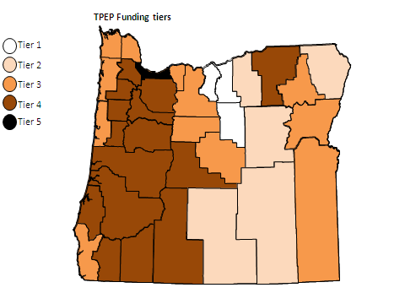

Current funding formula:

|  |  |  |
| --- | --- | --- |
|  | County Population: | Base: |
| Tier 1 | 0-2,999 | $16,250 |
| Tier 2 | 3,000-14,999 | $32,500 |
| Tier 3 | 15,000-59,999 | $48,750 |
| Tier 4 | 60,000-599,999 | $65,000 |
| Tier 5 | 600,000 and over | $81,250 |

Tier 1 (populations from 0-2,999): Sherman, Gilliam and Wheeler Counties

Tier 2 (populations from 3,000-14,999): Grant, Harney, Lake, Morrow and Wallowa Counties

Tier 3 (populations from 15,000-59,999): Baker, Clatsop, Columbia, Crook, Curry, Hood River, Jefferson, Lincoln, Malheur, Wasco and Wallowa Counties

Tier 4 (populations from 60,000-599,999): Benton, Clackamas, Coos, Deschutes, Douglas, Jackson, Josephine, Klamath, Lane, Linn, Marion, Polk, Umatilla, Washington and Yamhill Counties

Tier 5 (populations of 600,000 and over): Multnomah County

*North Central Health District receives combined base funding for Wasco, Sherman and Gilliam counties.

**Scenario #1: Combine first and second tiers of funding**

|  |  |
| --- | --- |
| County Pop: | Base: |
| 0-14,999 | $32,500 |
| 15,000-59,999 | $48,750 |
| 60,000-599,999 | $65,000 |
| 600,000 and over | $81,250 |

This scenario increases the base funding for current Tier 1 counties.

**Scenario #2: Combine first, second and third tiers of funding**

|  |  |
| --- | --- |
| County Pop: | Base: |
| 0-59,999 | $48,750 |
| 60,000-599,999 | $65,000 |
| 600,000 and over | $81,250 |

This scenario increases the base funding for current Tier 1 and Tier 2 counties.

**Scenario #3: Combine first, second, third and fourth tiers of funding**

|  |  |
| --- | --- |
| County Pop: | Base: |
| 0-599,999 | $65,000 |
| 600,000 and over | $81,250 |

This scenario increases the base funding for current Tier 1, Tier 2 and Tier 3 counties.