The Packaging and Labeling Rules Advisory Committee (P&L RAC) is addressing those provisions of HB 2546 that instruct the Oregon Health Authority to promulgate rules for child-resistant packaging, packaging not attractive to minors and labeling requirements for inhalant delivery systems.

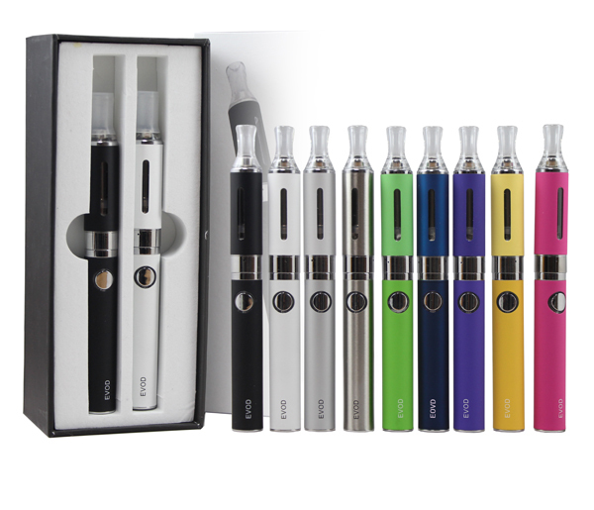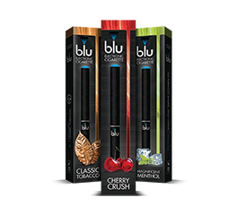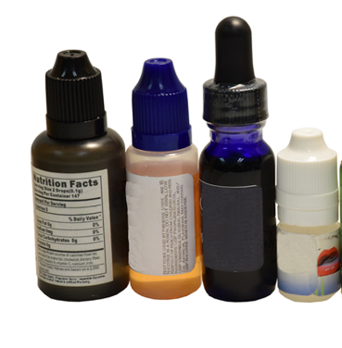“Inhalant delivery systems” (IDS) were defined by the legislature in the statute. IDS encompasses all components, including both nicotine-containing liquids and vaping devices, whether these items are sold pre-filled or not, and whether together or separately. Rules will need to clearly define requirements for each.

**Pre-filled IDS Liquid Nicotine Container Fillable IDS**

The P&L RAC has met four times to discuss concepts. The next meeting is on December 7, 2015. The goal is file the rules with the Secretary of State on January 15, 2015. After weighing evidence, feasibility and P&L RAC input, HPCDP is proposing the following:

**Child-resistant packaging**

* Require for all IDS liquids (nicotine and nicotine-free), consistent with legislative intent expressed during hearings.
* Do not require for pre-filled IDS of fillable IDS.

**Packaging not attractive to minors**

* Prohibit cartoons and depictions of celebrities or characters.
* Prohibit depictions of food or beverage products (e.g. grapes).
* Prohibit images of people who appear to be minors, and images of people consuming the product.
* Prohibit package shape (e.g., honey bear) or manner of dispensing (e.g., Pez) attractive to minors.

**Labeling**

* Prohibited content: any claims that do not meet the FDA Significant Scientific Agreement (SSA) standard. Current SSA would prohibit claims that the IDS aids in cessation, or is healthier or safer than tobacco.
* Required content: manufacturer contact, ingredients in descending order of predominance, milligrams of nicotine in the package, concentration of nicotine per mL, warning label, poison center number.
* Required design elements: specified font types and sizes that are clearly legible, and printed in English (with other languages permitted), and specify the location of the warning label.
* Required warning label content: keep out of reach of children, not to be sold or distributed to minors. Include language on nicotine’s toxic effects, side effects (e.g., dizziness) and potential for addiction.