The Indoor Clean Air Act (ICAA) Rules Advisory Committee (RAC) is addressing changes to the ICAA based on the definitions of “Inhalant Delivery Systems” (IDS) and “inhalants” that were set forth by the legislature in statute. Throughout the ICAA, where there is language around prohibiting smoking, we revising the rules to include aerosolizing and vaporizing.

The most significant area for RAC is around the definition of “enclosed area,” which was withdrawn from statute, with authority given to OHA to write the definition in rule.

**Current definition** of enclosed area in rule: all space between a floor and a ceiling that is enclosed on three or more sides by permanent or temporary wall or windows, exclusive of doors or passageways that extend from the floor to the ceiling.

The current definition, as it is worded in statute, is difficult to enforce. In 2014, OHA received 593 complaints, many of which were not valid because they didn’t violate the ICAA (e.g., not smoking in an enclosed area).

The new definition of “enclosed area” will clarify that areas such as those shown below are enclosed.

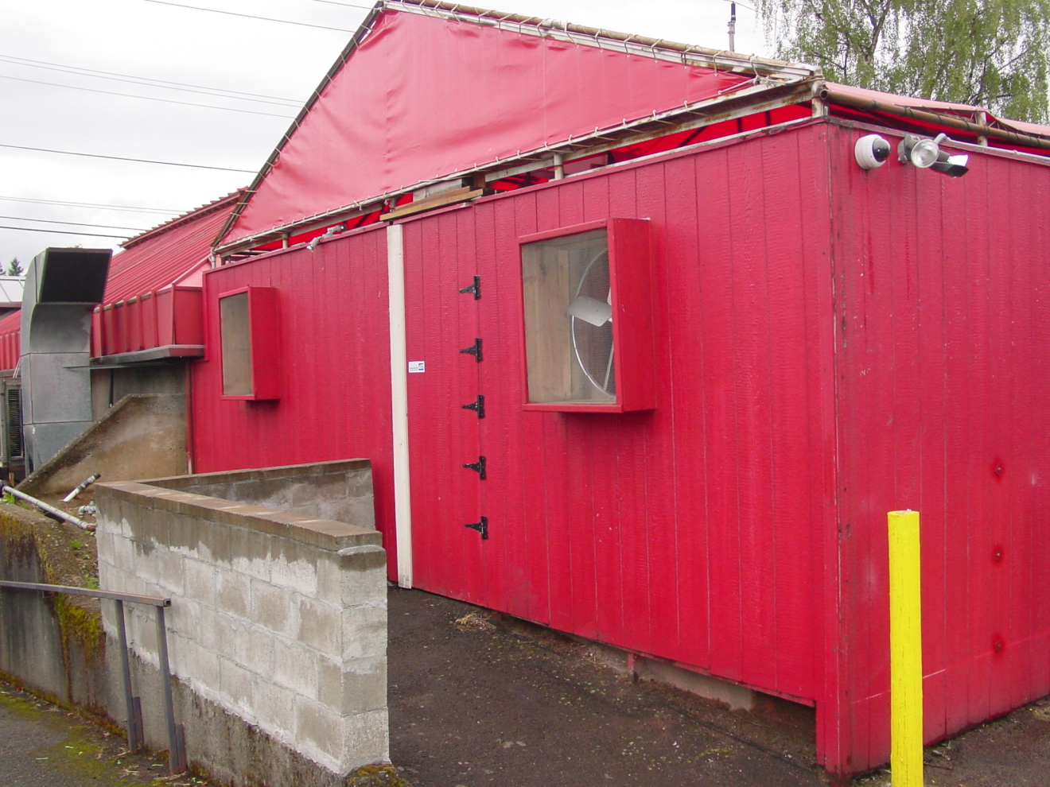 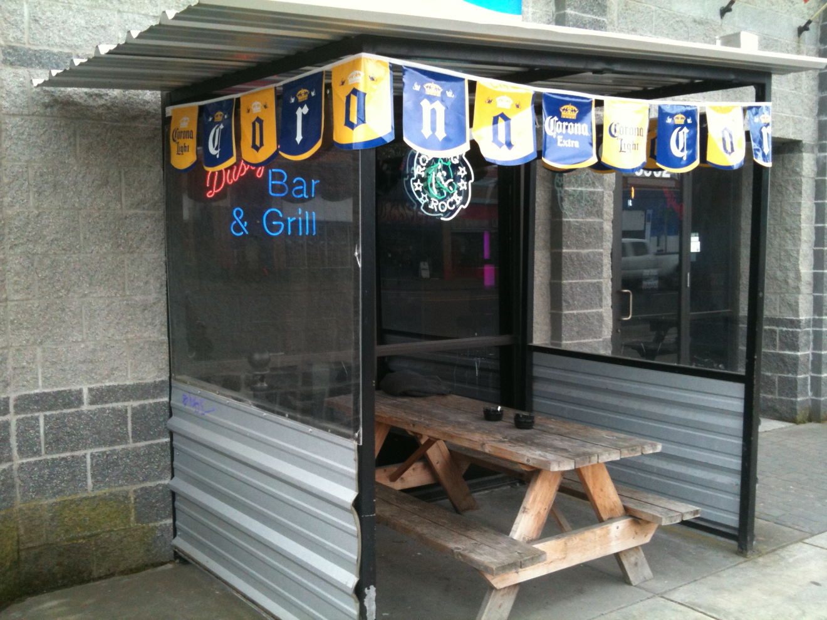

**Proposed definition** of enclosed area: all space between a floor and a ceiling that is enclosed on two or more sides by permanent or temporary walls or windows, exclusive of doors or passageways. If no ceiling is present, “enclosed area” means all space that is included by three or more sides by permanent or temporary walls or windows, exclusive of doors or passageways.

The proposed definition adds courtyards, which is similar to Benton County’s ICAA ordinance. Compared to the prior definition, this is both stronger to protect public health and clearer for businesses to understand.

**3 walls with no ceiling 2 walls and a ceiling**

 