**CLHO HEALTH PROMOTION AND PREVENTION COMMITTEE**

**Charter**

**Adopted January 25, 2018**

**Establishment and Authority**

ORS 435.330 Conference of Local Health Officials – “shall consist of all local health officers and public health administrators and such other local health personnel as may be included by the rules of the conference.” The Conference bylaws have organized the Conference to include a vote for each Local Public Health Administrator, a representative of each caucus (Health Officers, Public Health Administrators, Environmental Health Specialists and Public Health Nursing Supervisors), and the CLHO Executive Committee (which can be elected from general

membership, not just board members).

ORS 431.340 – 431.345 - The Conference may submit to the Oregon Health Authority such recommendations on the rules and standards for Minimum Standards for financial assistance – to include education and organization, operation and extent of activities, which are required or

expected of local health departments to carry out their responsibilities in implementing the public health laws of the state.

To fulfill the statutory obligations set forth in ORS 431 the Conference has organized itself into committees, which make recommendations to the full Conference Board.

**Public Health Modernization Background**

A new framework for state and local health departments was adopted in 2015 through House Bill 3100. The public health modernization framework depicts the core services that must be available to ensure critical public health protections for every individual in Oregon. Oregon’s modernized public health system is built upon seven foundational capabilities and four foundational programs. These foundational capabilities and programs encompass the core public health system functions that must be in place in all areas of the state. Foundational capabilities are the knowledge, skills and abilities needed to successfully implement foundational programs. Foundational programs include topic- and disease-specific work to improve health outcomes, such as a decrease in the prevalence of a particular disease or health risk behavior.

As Oregon’s governmental Public Health System continues on the Modernization journey, each committee will work to align community needs, contract requirements (program elements) and current programs with the foundational programs and capabilities as outlined in the Public Health Modernization Manual. Accountability metrics and process measures will also need to be discussed, along with identifying funding needed to fully implement modernization.

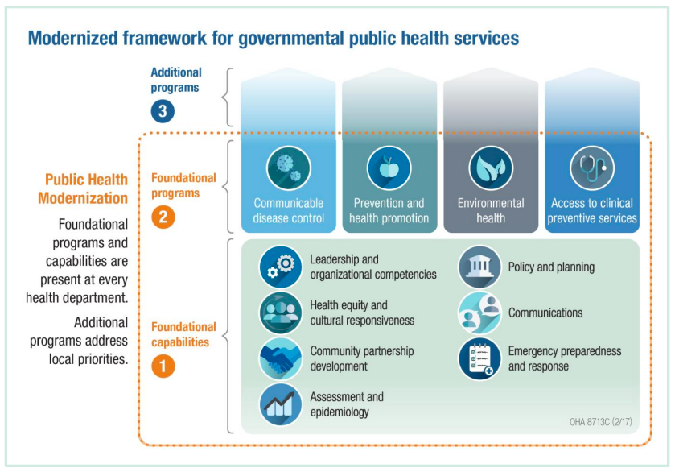

**Purpose of CLHO Committees**

Committees:

1. Shall meet the needs of the Conference.
2. Shall focus on one of the following Public Health Modernization areas: communicable disease control; prevention and health promotion; environmental health; access to clinical preventive services; systems and innovation; emergency preparedness and response; or another as-needed area that is relevant for protecting the health of Oregonians.
3. Will make recommendations to the Conference Executive Committee and Board of Directors on:
   1. Program elements proposed changes and updates
   2. Funding formula changes
   3. Other topic areas that are brought to the Committees by the PHD, CLHO, or Local Public Health Authorities.

**Prevention & Health Promotion Committee**

I. Purpose

The Prevention & Health Promotion committee would provide guidance and recommendations for existing and new areas of work as it relates to collecting and disseminating relevant data; developing plans to address health needs; and improving social, emotional, and physical health and safety especially as it relates to tobacco-use, alcohol drug misuse and abuse, nutrition, physical activity, oral health, childhood and maternal health, and intentional and unintentional injuries.

Areas of work to be addressed by the committee:

* Tobacco Prevention and Education
* Healthy Communities
* Prescription Drug Overdose
* Alcohol and Drug Prevention and Education
* Maternal, Child and Adolescent Health
* Teen Pregnancy
* Suicide Prevention

II. Terms

Terms for committee are two years. Every two years committee members need to be re-appointed and Committee Chairs appointed by the CLHO Board Chair.

III. Type of Committee

Standing

IV. Composition and Governance

Composition guidelines

Up to two committee members for each committee from each local public health jurisdiction are recommended by their county’s CLHO Board member, reviewed by CLHO Executive Committee and appointed by the CLHO Chair. Representatives should include public health administrators and public health managers with specific content expertise. Every two years the CLHO Executive Committee will review the composition of committees and strive for representation of at least two administrators and balanced representation from small (>40,000 people), medium (40,000 – 150,000 people), and large (150,000<) counties. If the number of committee members is too low to meet the needs of the committee, the Co-Chairs will be responsible for notifying CLHO Chair and initiating recruitment for more members.

Decision-making

The CLHO Committee works to reach consensus, which is defined as a willingness to move forward without strong objection. The Committee Chair provides recommendation to the CLHO Board and, if approved by the CLHO Board, the CLHO Board then makes recommendations to the PHD. Two committee members are allowed per jurisdiction, but only one vote is allowed per jurisdiction. If appointed members are not able to participate in the meeting, the jurisdiction could send someone to participate from the jurisdiction in proxy. If there is a time sensitive item, an email vote could be organized by the chairs with representation of one vote per county.

Committee Member Roles

* Attend and prepare for meetings as scheduled
* Volunteer for committee tasks to share the workload and promote timely completion of projects
* Utilize the CLHO Committee structure to its full potential
* Agree to participate for a minimum of two years
* Non-administrators report committee action to the administrator
* Local public health administrators serving on the committee bring a system-wide perspective on system impacts of program-specific strategy and implementation
* Notify the Committee Chair of their intent to resign

Committee Co-Chair Roles

* Plan future agendas with the PHD and committee members
* Set meeting dates and communicate meeting information
* Create agendas using CLHO agenda template that facilitate planning, availability of participants and preparation
* Conduct role call and determine quorum
* Facilitate meetings which includes explicitly agreeing on and communicating desired outcomes for each agenda item; specifying the process that will be used; assigning responsibility for any necessary follow up; as appropriate and mutually agreed upon, inviting guests to the meetings to share information; and coordinate the timeframe for project completion
* Post agendas and meeting materials on CLHO website in advance of the meeting
* Assure meeting minutes are prepared, communicated, and posted on the CLHO Website
* Proactively notify CLHO Board and PHD staff of significant issues related to statutory/rule changes, policy, funding or guideline changes
* Present updates or requests for recommendation approval or guidance to CLHO with ten days prior notice
* Serve as the primary contact for the Public Health Division for committee work
* Maintain current list of membership and request recruitment from CLHO when necessary
* Submit current list of members to CLHO Executive Committee every two years
* Present annual report to CLHO Board of Directors using CLHO provided template

VI. Meetings

Committee meetings will be held on the 4th Thursday of every month from noon-2 pm via conference call or webinar. The meetings will be open to the public, but only appointed members may participate during the meeting. However, the public may participate during a public comment time held in the last ten minutes of each committee meeting.

VII. Communications

The Committee is expected to annually present to the Conference Board a current status report, membership, and identify future issues and a strategic plan to address those issues.

The Committee may need to coordinate with other committees or create ad hoc subcommittees or joint committees to bring together the appropriate local health officials for thoughtful review and recommendation. Contact for Local and PHD Leads for each Committee, as well as each committee’s program elements, can be found on the oregonclho.org website.

IIX. Workplan

Every committee is expected to produce an annual workplan using the CLHO provided template.

**General Overview of all Standing CLHO Committees**

|  |  |
| --- | --- |
| Committee | Committee Duties |
| Systems and Innovation | PH accreditation alignment; foundational capabilities; annual expenditure data collection and reporting; data systems and interoperability; triennial review; committee guidelines for coordination |
| Emergency Preparedness and Response | Cities Readiness Initiative; PH Emergency Preparedness; System functions in an emerging event |
| Access to Clinical Preventive Services | WIC; Reproductive Health; SBHCs; Ryan White |
| Communicable Disease | State Support for PH; Tuberculosis; HIV; STD; Immunizations |
| Prevention and Health Promotion | Sustainable Relationships for Community Health; TPEP; Healthy Communities; Prescription Drug Overdose Prevention; Maternal, Child and Adolescent Health; Teen Pregnancy Prevention; Marijuana & Alcohol Prevention and Treatment |
| Environmental Health | Drinking Water; Environmental Health IGA; Domestic Well Safety; Climate and Health; Brownfields; Health Impact Assessments; Lead Line |