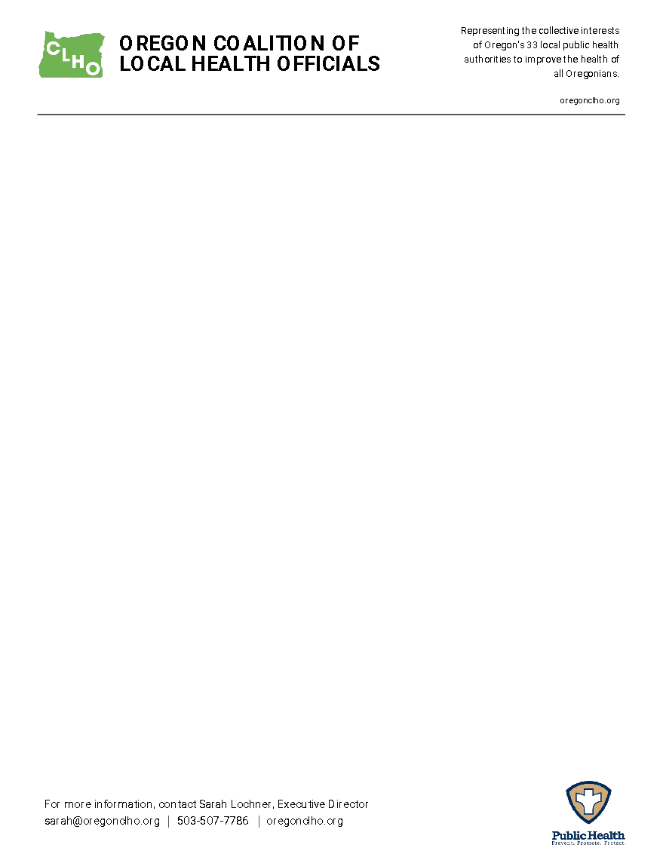

**Oregon Coalition of Local Health Officials**

**Declaration of Policy Principles**

*Board Approved 11/16/23*

*Committee Approved 09/04/25*

Public policy is a foundational tenant of public health, as a major driver of societal behavior change – for individuals, organizations, and communities. As such, good public policy is a key strategy for achieving public health goals.

“Legally binding public policies fall into 3 primary categories: legislation, regulation, and litigation” ([Porter 2018](https://www.ncbi.nlm.nih.gov/pmc/articles/PMC6243447/)). Because CLHO has not historically gotten involved in litigation, this declaration will focus on legislative policy and executive branch regulation.

CLHO hereby supports, and gives advocacy permission to its staff regarding, state or federal level policy proposals and regulations that:

* Increase state or federal government funding to support local public foundational capabilities, programs, health workforce, services, and infrastructure. Examples may include, but are not limited to funding for:
* Women, Infants, and Children (WIC), Maternal and Child Health Programs, , etc.
* Public health workforce supports through educational scholarships, increased higher education capacity, internships, public health rotations, student loan reimbursement or forgiveness, retention bonuses, tax credits, or other incentives.



* Primary prevention programs across the lifespan related to substance use, mental illness and suicide, problem gambling, injury/violence, chronic disease, early childhood/healthy starts, and/or houselessness.
* Limit access to substances harmful to human health including, but not limited to, tobacco, vapes, nicotine products, cannabis, illicit drugs, alcohol, toxic chemicals, known carcinogens, sugar, lead, etc.
  + Access may be restricted through time, place, manner, or age, increased prices or taxes, increased regulation on manufacturers, or other means.
* Increase access to, and rates of, FDA or state approved vaccinations.
* Increase access to communicable disease prevention, testing, and treatment.
* Support a robust Public Health Lab as a vital component of the Oregon public health system in rapidly detecting and protecting communities from public health threats.
* Support for robust public health data systems and efforts to expand/improve health and public health data collection and coordination.
* Support a strong system of improving local and state capacity to assess and manage risks associated with private wells to protect both the lifelong health of Oregonians and the state's groundwater resources.



* Support sustaining and building the capability and capacity for emergency preparedness operations of every local health department in Oregon.
* Increase access to the full array of healthcare services across the lifespan.
* Are needed to meet the requirements or goals of a grant CLHO has received.

When the impacts of funding or a policy are uncertain, far-reaching, or particularly controversial, CLHO staff will consult with the Legislative Committee. When time constraints exist and the Legislative Committee cannot be consulted, CLHO staff will consult with the Legislative Committee Co-Chairs and/or the Executive Committee.

This document will be reviewed every two years, in the fall/winter of odd numbered years (prior to short session).