**Ballot Measure 108 County Funding Scenarios |** May 18, 2022

CLHO Prevention and Health Promotion Committee

**Background**

* About $14.5 million in tobacco tax revenue has not been budgeted for 2021-2023.
* OHA is now working with the Conference of Local Health Officials to determine BM 108 funding allocation for LPHA’s to further strengthen equity efforts and expand capacity to work in partnership with CBOs and other tobacco prevention system partners.
* The magnitude of unbudgeted funds will likely not be this high in future biennia so sustainability of workplan revisions should be taken into consideration; however, activities related to centering equity and community partnerships could inform workplans and budget requests in future biennia.
* OHA must also consider what resources are needed to support statewide infrastructure for cessation, health communication, and data collection and evaluation, including any emerging training and technical assistance needs from LPHAs and new CBO grantees.

**Funding Framework**

The funding framework below includes three high-level “activity buckets” that could be considered in revised TPEP workplans. Counties could revise their current TPEP workplans to include one or more of the following activity buckets depending on capacity and readiness for new and/or enhanced health equity and community partnerships work.

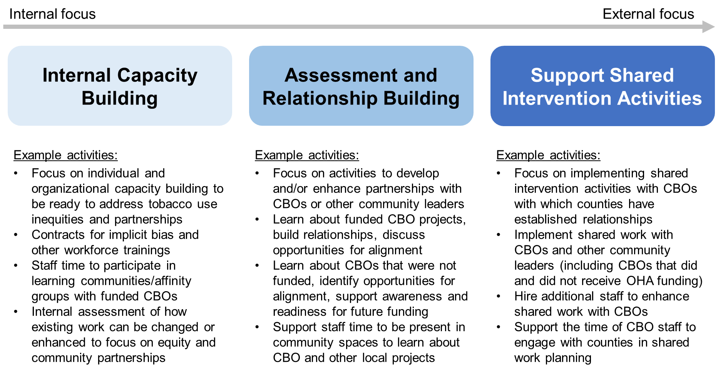

**Funding Allocation Scenarios**

The following three scenarios describe how funding could be allocated to implement activities described in the funding framework. The following consideration were taken into account in developing these scenarios: flexibility, capacity, TPEP funding tiers, CBO funding, and county population demographics.

***Scenario 1: Lump sum funding for each activity bucket***

This scenario would offer a lump sum of funding for each activity bucket: **$50,000** for internal capacity building, **$100,000** for external assessment and relationship building and **$200,000** for shared intervention implementation. Loosely, these funding amounts could equate to a partial, half, or full FTE to support activities. Movement between these activity buckets can be flexible and dependent on evolving capacity and readiness. In addition, a funding range could be considered for each activity bucket. Funding for statewide infrastructure would be considered in relation to the total funding request.

***Scenario 2: TPEP tiered funding***

The current TPEP Tiered funding formula could be used to allocate unbudgeted funds. Tiered funding amounts are based on the tier counties opted into and the range of funding that could be requested under each tier. Under this scenario, unbudgeted funds would be allocated to each county at the same proportion as Measure 44 funding. For example, Benton County received 3.9% of total Measure 44 dollars allocated to counties, so would receive the same proportion of total Ballot Measure 108 dollars allocated to counties. **Table 1** below shows county allocations under this scenario at total funding levels of $7 million (CDC recommended allocation) and $10 million (amount requested in CLHO letter).

***Scenario 3: Public Health Modernization funding formula***

The Public Health Modernization funding formula could be used to allocate unbudgeted funds. The funding formula considers the following population characteristics for county allocations: population size, premature death, quality of life, race and ethnicity, poverty, rurality, educational attainment, and limited English language proficiency. **Table 2** below shows county allocations under this scenario.

***Scenario 4: Geographic parity of CBO funding***

This scenario would base allocations on the funding needed to bring each county to the same average per capita spending based on CBO funding in each county. In this scenario, average per capita funding was calculated for each county based on the “counties served” indicated by CBOs receiving commercial tobacco prevention grants. Then the “additional funding” required for each county to achieve a per capita funding equal to the average ($4.44) was calculated. Under this scenario, counties with funding to CBOs at or above the average would not receiving additional funding. This scenario would not provide additional funding to counties at or above the average per capita funding awarded to CBOs. This may conflict with the concept that both counties with and without funded CBOs require funding to support partnership development and shared work. **Table 3** below shows the funding allocations to each county based on this scenario that prioritizes equal per capital spending based on CBO grant awards in each county.

***[NEW] Scenario 5: Modified Public Health Modernization funding formula***

A modified Public Health Modernization funding formula could be used to allocate unbudgeted funds. The base funding formula considers the following population characteristics for county allocations: population size, premature death, quality of life, race and ethnicity, poverty, rurality, educational attainment, and limited English language proficiency. The modified formula replaces premature death with burden of tobacco use measured as the percentage of adults who currently use tobacco (including cigarettes, little cigars, large cigars, hookah, electronic cigarettes and/or smokeless tobacco). **Table 4** below shows county allocations under this scenario.

**Example Equity-Focused State TPEP Activities for Unbudgeted Funds**

State TPEP staff brainstormed examples of equity-focused activities for the unbudgeted funds across the program areas of cessation, health communications, and data collection and evaluation. In addition, state staff considered that unbudgeted funds could support the Community Policy Leadership Institutes, a longer-term community advisory group, and developing a learning communities model.

**Cessation**

* Ensure continued access to eight weeks of expedited NRT (est. during EVALI response)
* Support community and clinical partners to build out EHR referral processes/systems to the Tobacco Quit Line for culturally specific populations

**Health communications**

* Implement new tobacco cessation campaign based on updated research
* Fund paid promotion of *Vive Sin Fumar*, Oregon’s first Spanish cessation media campaign
* Fund paid promotion of culturally specific tobacco prevention ads
* Fund updated, paid promotion of *We See/They See* campaign
* Maintain strategic communications technical assistance for RHECs and other partners (e.g., Oregon Office on Disability and Health)

**Data collection and evaluation**

* Evaluate Quit Line to determine how service is meeting needs of culturally specific groups
* Evaluate how existing cessation services support culturally specific communities to quit
* Evaluate health care system interventions to support CCO members to quit tobacco
* Evaluate Native Quit Line promotional campaign (contract with Northwest Portland Area Indian Health Board)
* Evaluate Community Policy Leadership Institute (CPLI)

**Table 1.** Funding Allocations to Counties using TPEP Tiered Funding (Scenario 2)

*These are example dollar amounts for planning and conversation.*

|  |  |  |  |
| --- | --- | --- | --- |
| **County** | **Tier** | **Allocation with $7 million total** | **Allocation with $10 million total** |
| Baker | Tier 2 | $110,241 | $157,487 |
| Benton | Tier 3 | $271,631 | $388,044 |
| Clackamas | Tier 3 | $665,109 | $950,156 |
| Clatsop | Tier 3 | $312,528 | $446,469 |
| Columbia | Tier 1 | $73,769 | $105,384 |
| Coos | Tier 2 | $114,993 | $164,276 |
| Crook | Tier 3 | $203,370 | $290,528 |
| Curry | Tier 1 | $65,448 | $93,497 |
| Deschutes | Tier 3 | $382,959 | $547,084 |
| Douglas | ICAA only | $27,401 | $39,144 |
| Gilliam, Sherman, Wasco | Tier 2 | $180,906 | $258,437 |
| Grant | Tier 1 | $52,607 | $75,152 |
| Harney | Tier 2 | $93,388 | $133,412 |
| Hood River | Tier 3 | $244,659 | $349,512 |
| Jackson | Tier 2 | $183,208 | $261,725 |
| Jefferson | Tier 2 | $195,718 | $279,597 |
| Josephine | Tier 2 | $158,190 | $225,986 |
| Klamath | Tier 2 | $152,237 | $217,482 |
| Lake | ICAA only | $11,743 | $16,776 |
| Lane | Tier 3 | $665,442 | $950,631 |
| Lincoln | Tier 2 | $195,509 | $279,299 |
| Linn | Tier 3 | $321,482 | $459,260 |
| Malheur | Tier 2 | $149,662 | $213,803 |
| Marion | Tier 2 | $195,718 | $279,597 |
| Morrow | ICAA only | $11,743 | $16,776 |
| Multnomah | Tier 3 | $665,442 | $950,631 |
| Polk | ICAA only | $11,743 | $16,776 |
| Tillamook | Tier 2 | $146,807 | $209,725 |
| Umatilla | Tier 3 | $267,171 | $381,673 |
| Union | Tier 1 | $84,550 | $120,786 |
| Wallowa | N/A | N/A | N/A |
| Washington | Tier 3 | $584,946 | $835,637 |
| Wheeler | ICAA only | $11,743 | $16,776 |
| Yamhill | Tier 2 | $187,937 | $268,482 |
| **Total** |  | **$7,000,000** | **$10,000,000** |

**Table 2.** Funding Allocations to Counties using Public Health Modernization Funding Formula (Scenario 3)

*These are example dollar amounts for planning and conversation.*

|  |  |  |
| --- | --- | --- |
| **County** | **Allocation with $7 million total** | **Allocation with $10 million total** |
| Baker | $51,941 | $64,570 |
| Benton | $152,764 | $206,693 |
| Clackamas | $502,889 | $744,354 |
| Clatsop | $94,684 | $123,465 |
| Columbia | $112,551 | $151,813 |
| Coos | $135,038 | $187,489 |
| Crook | $78,641 | $98,012 |
| Curry | $76,084 | $93,955 |
| Deschutes | $258,796 | $366,001 |
| Douglas | $216,827 | $308,334 |
| Gilliam, Sherman, Wasco | $150,087 | $175,688 |
| Grant | $43,437 | $51,078 |
| Harney | $39,581 | $44,960 |
| Hood River | $93,581 | $121,715 |
| Jackson | $326,992 | $474,199 |
| Jefferson | $91,533 | $118,466 |
| Josephine | $185,356 | $258,403 |
| Klamath | $144,245 | $202,097 |
| Lake | $43,244 | $50,771 |
| Lane | $497,355 | $735,574 |
| Lincoln | $112,782 | $152,179 |
| Linn | $214,140 | $304,070 |
| Malheur | $104,430 | $138,927 |
| Marion | $577,765 | $872,069 |
| Morrow | $57,291 | $73,058 |
| Multnomah | $1,056,526 | $1,622,741 |
| Polk | $156,419 | $212,492 |
| Tillamook | $88,069 | $112,969 |
| Umatilla | $191,484 | $268,126 |
| Union | $76,990 | $95,392 |
| Wallowa | $42,574 | $49,708 |
| Washington | $802,114 | $1,219,096 |
| Wheeler | $32,868 | $34,308 |
| Yamhill | $190,920 | $267,231 |
| **Total** | **$7,000,000** | **$10,000,000** |

**Table 3.** Funding Allocations to Counties to Achieve Per Capita Funding Equal to State Average (Scenario 4)

*These are example dollar amounts for planning and conversation.*

|  |  |  |
| --- | --- | --- |
| **County** | **CBO funding per capita** | **Additional funding to equal state average ($4.44)** |
| Baker | $5.19 | N/A |
| Benton | $2.20 | $212,057 |
| Clackamas | $5.62 | N/A |
| Clatsop | $0.44 | $157,750 |
| Columbia | $1.59 | $151,698 |
| Coos | $3.22 | $77,263 |
| Crook | $0.13 | $100,916 |
| Curry | $0.13 | $99,043 |
| Deschutes | $0.45 | $786,894 |
| Douglas | $0.42 | $451,976 |
| Gilliam, Sherman, Wasco | $5.78 | N/A |
| Grant | $2.13 | $16,868 |
| Harney | $2.13 | $16,788 |
| Hood River | $5.68 | N/A |
| Jackson | $3.67 | $171,672 |
| Jefferson | $0.21 | $102,048 |
| Josephine | $2.95 | $128,671 |
| Klamath | $3.46 | $66,622 |
| Lake | $0.13 | $34,765 |
| Lane | $0.62 | $1,456,195 |
| Lincoln | $8.97 | N/A |
| Linn | $1.34 | $394,252 |
| Malheur | $2.33 | $67,817 |
| Marion | $2.33 | $737,789 |
| Morrow | $2.21 | $28,653 |
| Multnomah | $9.93 | N/A |
| Polk | $0.55 | $325,685 |
| Tillamook | $0.25 | $111,092 |
| Umatilla | $2.21 | $182,075 |
| Union | $5.43 | N/A |
| Wallowa | $5.04 | N/A |
| Washington | $5.82 | N/A |
| Wheeler | $5.37 | N/A |
| Yamhill | $1.20 | $352,024 |
| **Total** |  | **$6,230,612** |

**[NEW] Table 4.** Funding Allocations to Counties using Modified Public Health Modernization Funding Formula (Scenario 5)

*These are example dollar amounts for planning and conversation.*

|  |  |  |  |
| --- | --- | --- | --- |
| **County** | **Allocation with $7 million total** | **Allocation with $10 million total** | **Allocation with $14.5 million total** |
| Baker | $52,951 | $66,172 | $95,950 |
| Benton | $149,466 | $201,460 | $292,117 |
| Clackamas | $505,399 | $748,336 | $1,085,087 |
| Clatsop | $96,563 | $126,445 | $183,346 |
| Columbia | $113,149 | $152,761 | $221,504 |
| Coos | $135,579 | $188,347 | $273,104 |
| Crook | $81,596 | $102,699 | $148,914 |
| Curry | $74,809 | $91,932 | $133,301 |
| Deschutes | $269,145 | $382,422 | $554,511 |
| Douglas | $206,427 | $291,834 | $423,159 |
| Gilliam, Sherman, Wasco | $150,140 | $175,772 | $254,869 |
| Grant | $42,936 | $50,282 | $72,908 |
| Harney | $39,959 | $45,559 | $66,061 |
| Hood River | $92,603 | $120,164 | $174,237 |
| Jackson | $321,265 | $465,113 | $674,413 |
| Jefferson | $91,233 | $117,989 | $171,085 |
| Josephine | $184,614 | $257,225 | $372,977 |
| Klamath | $143,480 | $200,883 | $291,280 |
| Lake | $42,588 | $49,729 | $72,107 |
| Lane | $497,257 | $735,419 | $1,066,357 |
| Lincoln | $113,232 | $152,892 | $221,693 |
| Linn | $218,308 | $310,685 | $450,493 |
| Malheur | $103,246 | $137,049 | $198,721 |
| Marion | $575,777 | $868,916 | $1,259,928 |
| Morrow | $57,540 | $73,452 | $106,505 |
| Multnomah | $1,047,410 | $1,608,277 | $2,332,002 |
| Polk | $158,953 | $216,513 | $313,944 |
| Tillamook | $87,993 | $112,848 | $163,630 |
| Umatilla | $190,498 | $266,561 | $386,514 |
| Union | $76,234 | $94,192 | $136,579 |
| Wallowa | $42,048 | $48,872 | $70,865 |
| Washington | $807,681 | $1,227,930 | $1,780,498 |
| Wheeler | $33,161 | $34,774 | $50,422 |
| Yamhill | $196,760 | $276,496 | $400,919 |
| **Total** | **$7,000,000** | **$10,000,000** | **$14,500,000** |