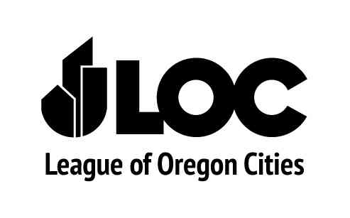

We are writing as part of a large coalition of organizations to support the increase in minimum pricing to proposed by OLCC staff. Oregon’s local governments are preempted from taxing or providing meaningful alcohol regulation and must rely on shared revenue from the state to compensate them on the cost associated with overconsumption and abuse. The state is not the primary responder to alcohol related incidents such as DUIIs, domestic disturbances, welfare checks, and addressing the public health implications of alcohol addiction.

It is our understanding that the current minimum price for a 750 ml bottle of an 80 proof alcoholic beverage is $6.39, which equates to a per drink price of $.38 (a drink is defined as 15 grams of pure alcohol). It is our further understanding there are 41 products, out of approximately 9,500 in the OLCC inventory, that account for 15% of total OLCC sales. These inexpensive items clearly have a disproportionate impact relative to the revenue they generate for the state and local governments.

While we believe that these items are underpriced from an economic perspective, we also believe that it is inappropriate to sell an addictive substance with the potential for abuse for so little. Oregon has experienced a 34% increase in alcohol related deaths between 2001 and 2017, according to the Oregon Health Authority. Creating a reasonable minimum price is a simple step the OLCC can take to disincentivized the excessive consumption of alcohol. Further, the proposed pricing structure increases with the ABV of beverage, thus vectoring consumers towards lower alcohol content choices.

We, the local government associations, public safety agencies, public health providers of Oregon support the draft price schedule crafted by the OLCC staff and urge it’s adoption.