**Conference of Local Health Officials**

**2021-23 modernization POP development and funding priorities**

January 16, 2020

**Purpose:** Hear timeline for modernization POP development and the process JLT will use to develop the POP. Provide feedback on 2021-23 funding priorities.

**Timeline for modernization POP development**

* **Jan-March:** JLT and PHD draft descriptions of 2021-23 work
* **Fall:** OHA Agency Request Budget released
* ***Feb-May:*** *(Related item)* PHAB will develop the 2021-23 modernization funding formula for LPHAs

**2021-23 funding priorities**

In 2018 PHAB made the following recommendations for 2019-21. These recommendations were supported by CLHO.

1. The public health system continue to focus on Communicable Disease Control, Health Equity and Cultural Responsiveness, and Assessment and Epidemiology; and
2. With additional funding, expand focus to include Environmental Health, Leadership and Organizational Competencies, and Emergency Preparedness and Response.

**CLHO discussion**

1. Does the phased approach effectively bring attention to the foundational capabilities as essential for effective public health programs?
2. 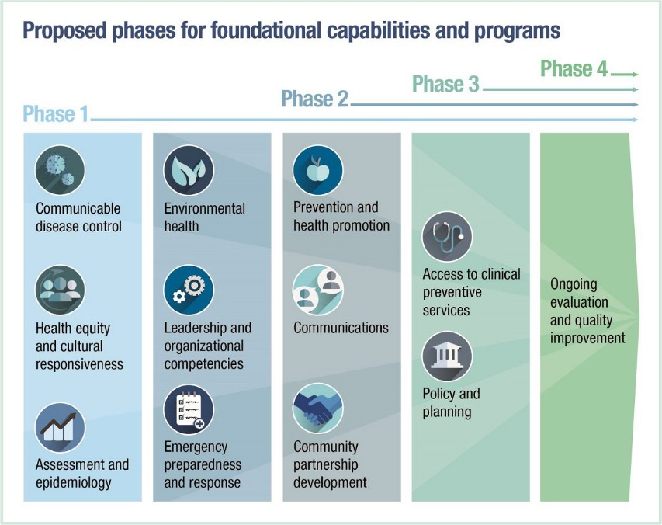Do CLHO members recommend changes to the funding priorities for 2021-23?