 | PUBLIC HEALTH DIVISION  HIV/STD/TB Section | 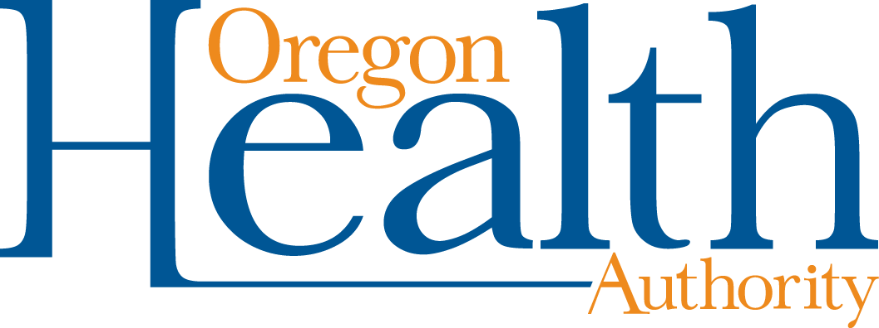
 | Kate Brown, Governor

800 NE Oregon Street, Suite 1105
Portland, OR 97232-2187
Voice 971-673-0153
Fax 971-673-0178
www.healthoregon.org/std

Program Element 10 (STD)
Syphilis set payment per case funding model

A new five-year CDC cooperative agreement (PS19-1901) to fund STD prevention activities at the state health department level began in January 2019. The cooperative agreement is organized into five strategy areas each with a subset of required activities:

- Conduct surveillance
- Conduct disease investigation and intervention
- Promote CDC-recommended screening, diagnosis, and treatment
- Promote STD prevention and policy
- Analyze and use data for program improvement
Four of the five strategies will be conducted primarily at the state health department level by OHA staff. Activities in the “conduct disease investigation and intervention” strategy area, specifically provision of case investigation activities for syphilis, require participation of local public health authorities.

Elimination of congenital syphilis and reduction of primary and secondary syphilis are called out as key goals of PS19-1901 with prevention of congenital syphilis identified as the highest priority of the new cooperative agreement. As a result, PS19-1901 identifies these specific groups for whom disease investigation and intervention activities should be conducted with CDC funds:

- All pregnant women with syphilis (any stage)
- All females of reproductive age (15-44) with syphilis with an emphasis on early syphilis cases (primary, secondary, early non-primary non-secondary)
- All males with early syphilis cases (primary, secondary, early non-primary non-secondary) who report female partners of reproductive age
Beginning July 1, 2019, the STD Program is proposing to use a set payment per case funding model to reimburse LPHAs for conducting syphilis case investigations with the three priority populations for which CDC requires case investigation and intervention work under PS19-1901. The proposed model for the STD program is similar to the model implemented by the TB program in 2018. Approximately one third of Oregon’s federal STD dollars, supplemented by state general fund dollars, as needed, will be available to reimburse LPHAs.

Based on a review of historical incidence, the STD program is proposing to reimburse LPHAs according to the following set payment per case model:

- Pregnant female syphilis case = $1,125
- Female syphilis case of reproductive age = $1,125
- Male early syphilis case with female partner of reproductive age = $500
Reimbursement will be provided through the PE10 monthly amendment process. Funding to support other STD case investigations has been made available through the HIV Early Intervention & Outreach Services (EISO) contract of which twelve LPHAs are recipients or sub-recipients. Additionally, LPHAs are eligible to apply for outbreak response/special needs funding from the STD Program to assist with STD case investigations that are large or challenging.

The following tables illustrate how funding would have been applied using 2018 STD case data:

Pregnant female syphilis cases
County | 2018 cases | Proposed reimbursement ($1,125)
Clackamas | 3 | $ 3,375
Coos | 1 | $ 1,125
Deschutes | 1 | $ 1,125
Douglas | 1 | $ 1,125
Hood River | 1 | $ 1,125
Jackson | 10 | $ 11,250
Lane | 3 | $ 3,375
Marion | 5 | $ 5,625
Multnomah | 12 | $ 13,500
Polk | 1 | $ 1,125
Union | 1 | $ 1,125
Washington | 3 | $ 3,375
Total | 42 | $ 47,250
Female syphilis cases of reproductive age
County | 2018 cases | Proposed reimbursement ($1,125)
Benton | 3 | $ 3,375
Clackamas | 10 | $ 11,250
Clatsop | 2 | $ 2,250
Columbia | 3 | $ 3,375
Coos | 2 | $ 2,250
Deschutes | 4 | $ 4,500
Douglas | 3 | $ 3,375
Hood River | 3 | $ 3,375
Jackson | 38 | $ 42,750
Josephine | 1 | $ 1,125
Lane | 9 | $ 10,125
Linn | 3 | $ 3,375
Marion | 23 | $ 25,875
Multnomah | 66 | $ 74,250
Polk | 3 | $ 3,375
Umatilla | 1 | $ 1,125
Union | 1 | $ 1,125
Washington | 12 | $ 13,500
Yamhill | 1 | $ 1,125
Total | 188 | $ 211,500
Male early syphilis cases with female partner of reproductive age
County | 2018 cases | Proposed reimbursement ($500)
Benton | 3 | $ 1,500
Clackamas | 14 | $ 7,000
Clatsop | 1 | $ 500
Coos | 2 | $ 1,000
Deschutes | 1 | $ 500
Douglas | 5 | $ 2,500
Hood River | 2 | $ 1,000
Jackson | 12 | $ 6,000
Klamath | 1 | $ 500
Lane | 7 | $ 3,500
Linn | 4 | $ 2,000
Marion | 22 | $ 11,000
Multnomah | 66 | $ 33,000
Washington | 20 | $ 10,000
Yamhill | 1 | $ 500
Total | 161 | $ 80,500
Total reimbursement by county
County | Total proposed reimbursement | Percentage of total reimbursement
Benton | $ 4,875 | 1.4%
Clackamas | $ 21,625 | 6.4%
Clatsop | $ 2,750 | 0.8%
Columbia | $ 3,375 | 1.0%
Coos | $ 4,375 | 1.3%
Deschutes | $ 6,125 | 1.8%
Douglas | $ 7,000 | 2.1%
Hood River | $ 5,500 | 1.6%
Jackson | $ 60,000 | 17.7%
Josephine | $ 1,125 | 0.3%
Klamath | $ 500 | 0.1%
Lane | $ 17,000 | 5.0%
Linn | $ 5,375 | 1.6%
Marion | $ 42,500 | 12.5%
Multnomah | $ 120,750 | 35.6%
Polk | $ 4,500 | 1.3%
Umatilla | $ 1,125 | 0.3%
Union | $ 2,250 | 0.7%
Washington | $ 26,875 | 7.9%
Yamhill | $ 1,625 | 0.5%
Total | $ 339,250 | 100.0%

