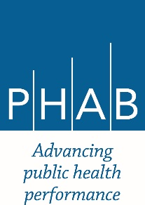

**Accredited Health Department Learning Event**

**OREGON**

**Tentatively Planned for October 2018**

Desired Outcomes:

* Invite Accreditation Coordinators and Health Department Directors from accredited health departments to convene for one day.
* The group will review the current annual report process, discuss the key components of reaccreditation, and brainstorm ways to cultivate a culture of quality improvement within their respective communities.

Funding:

A range of $8,000-$9,000 will be awarded through a fixed contract through PHAB to CLHO to cover lunch, mileage reimbursement, IT/AV needs, location costs and other logistical costs. This can cover an indirect rate of 10% to cover staff time associated to this event.