**INITIAL ANALYSIS OF STRATEGIC PLANNING**

**HUMAN SERVICES, EARLY CARE AND EDUCATION & K-12 DEBRIEFS**

**version 6.1.18**

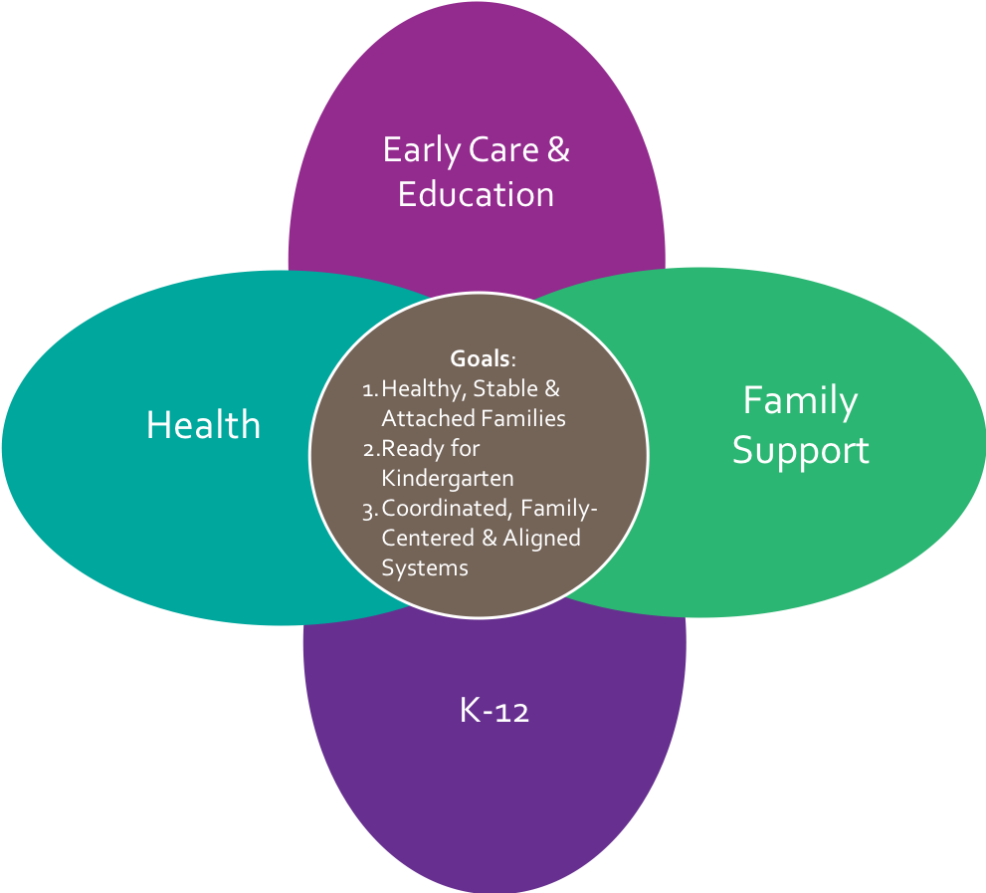

**Purpose of Strategic Plan**

The Early Learning Council Strategic Plan will describe the goals, strategies and activities that the Council will advance over five years from 2019 – 2024.

The Plan will represent what the Council considers as the most strategic to advance an Oregon early learning system for children ages prenatal to five and their families toward the vision or system goals that:

1. Children are raised in healthy, stable & attached families
2. Children arrive ready for kindergarten
3. Coordinated, family-center & aligned systems

The early learning system incorporates the coordination and alignment across key sectors, including Early Care and Education, Health, K-12, Family Support, e.g. Human Services, Housing & Community Services, etc.

**Strategic Plan Process**

The Early Learning Council has committed to a series of dedicated meetings to hear from stakeholders from each of the key sectors that include state agency and division leadership, program administrators, hubs and other regional entities, providers and families. Council members will also be participating in stakeholder engagements outside of the meeting structure and attending events around the state and bringing that information back to the full Council.

During the stakeholder engagements, Council members are listening for:

* Each sector’s key goals and priorities for children prenatal to five and their families,
* Strengths and barriers for reaching those goals and priorities,
* Opportunities for shared interests and work across sectors related to the three systems goals.

Council members are also listening for what would be most strategic in the next five years to advance an early learning system that has the capacity to support the development and well-being of children prenatal to age five nested in their families and communities.

Throughout the process, Council members are using the equity lens to engage diverse voices across the state and how it will be woven across the strategies in the strategic plan.

In addition to the engagement sessions held at the monthly Council meetings, the Early Learning Division is working to coordinate community listening sessions throughout the state from June through August, focusing on parents, child care providers, and Hub Governance Councils.

**Getting to the Strategic Plan**

The drafting of the strategic plan will be an iterative process with the Council members. It will be a process of capturing Council members’ expertise, learnings, and brainstorming from the stakeholder engagements, analyzing those debriefs, and making decisions of what is rising to the top as the most strategic in building the best Oregon early learning system over the next five years.

**Summary of Human Services, Early Care & Education, and K-12 Themes**

The following list summarizes the initial themes captured from the debriefs the Council had through discussion and submitted in writing after the stakeholder engagements that involved Human Services, Early Care & Educatio and K-12 sectors. At this point, the process is capturing as many themes as possible to ensure Council members’ observations and ideas have been described accurately. As part of the iterative process, themes will ultimately be combined and prioritized. Themes will continue to be honed and clarified during Council debrief sessions and as other sectors and stakeholders are engaged:

1. Cultural Responsiveness & Equity
2. Access to ECE
3. Affordability of ECE
4. Supply of ECE Settings
5. Quality of Settings
6. Standards/Regulations Alignment
7. Child Development Outcomes
8. Workforce
9. Trauma-Informed Care
10. Inclusion
11. Supporting Families
12. Family-Centered Systems
13. Use of Data
14. Financing & Leveraging Resources
15. Building a Systems Approach
16. State-Community Connections
17. Geographic Specific Needs
18. Community Context
19. Connecting with Business
20. Role of Early Learning Council

**Moving from Themes to Drafting the Plan’s Goals & Strategies**

Council members may begin to identify emerging goals and strategies for the strategic plan when reviewing the themes. There will be a process to do this more formally after themes are incorporated from the other sectors. The strategic plan could include different types of goals, including but not all encompassing:

* Sector-specific goals that contribute to an Oregon early learning system
* Sector-specific goals that contribute to the early care and education sector
* Cross-sector goals that will advance progress toward the systems vision of (1) Children are raised in healthy, stable & attached families, (2) Children arrive ready for kindergarten, and (3) Coordinated, family-center & aligned systems
* Alignment and coordination goals across sectors that will advance progress toward shared interests in child and family outcomes
* Issue or service-specific goals that more than one or all sectors share, e.g. trauma-informed care, cultural responsiveness & equity, family support services

**Parking Lot Items**

Parking lot items generated during the Human Services and ECE discussions have been organized into one or more of these three buckets:

* Items that could be incorporated into the themes and could become goals, strategies or activities in strategic plan
* Items that have service and policy implementation issues have been assigned to state agencies for follow-up, e.g. policy clarification and alignment between ERDC and TANF subsidized child care
* Items that Council members want to discuss to inform the strategic plan

**The Use of Language in the Strategic Plan**

Council members have started to identify how language should be used in the strategic plan:

* + Be clear about what the system is
  + Consider the implication of language, e.g. “affordability” of child care – if used by itself it will only consider what parents can afford, but our terminology should reflect what parents can afford, what are the true costs, what it takes to address equity, etc.
  + Need to build broad support for prevention and early learning
  + Include explanation of what is return on investment (ROI)
  + Need to think about globally regarding poverty vs. neglect and model language in the strategic plan that we want used elsewhere