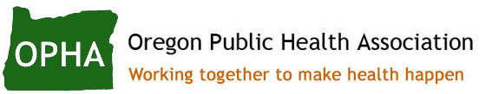

**Organizational Membership Perks**

* Increased visibility and recognition within Oregon’s vast public health community
* Connection to a community of peers to exchange ideas and build partnerships for public health year round
* The opportunity to work collaboratively with OPHA to establish common positions on critical policy issues
* Joining your voice with the OPHA network as an advocate to protect and promote the health of all Oregonians
* 15% discounted individual membership fees for employees
* One free individual membership for an employee of choice
* Featured on our website with your organization’s logo and a link to your webpage
* 10% discount on exhibit booths at the Annual Conference
* Recognition and materials placement with the OPHA table display at the Annual Conference

Learn more and join today at <https://opha.memberclicks.net/join>