Prevention Grant Projects in high-burden regions

Oregon identified high-burden regions throughout the state and awarded CDC and other prescription drug overdose prevention funding to these regions. Regions hire or designate staff to form multi-sector partnerships to: convene a Pain Guidance Group of health care providers, form an Interdisciplinary Action Team to monitor outcomes, boost local enrollment in the PDMP, host regional pain summits, encourage drug disposal programs in pharmacies, post online local resources for providers and patients, and work with local media on prevention and public awareness campaigns.

Regional pain symposia also educates the medical community about PDMP use, prescribing guidelines, pain management, medication assisted treatment (MAT), naloxone use and rescue, and behavioral health interventions to opioid dependency. This work is carried out throughout the county, regional and amongst CCO and health systems.
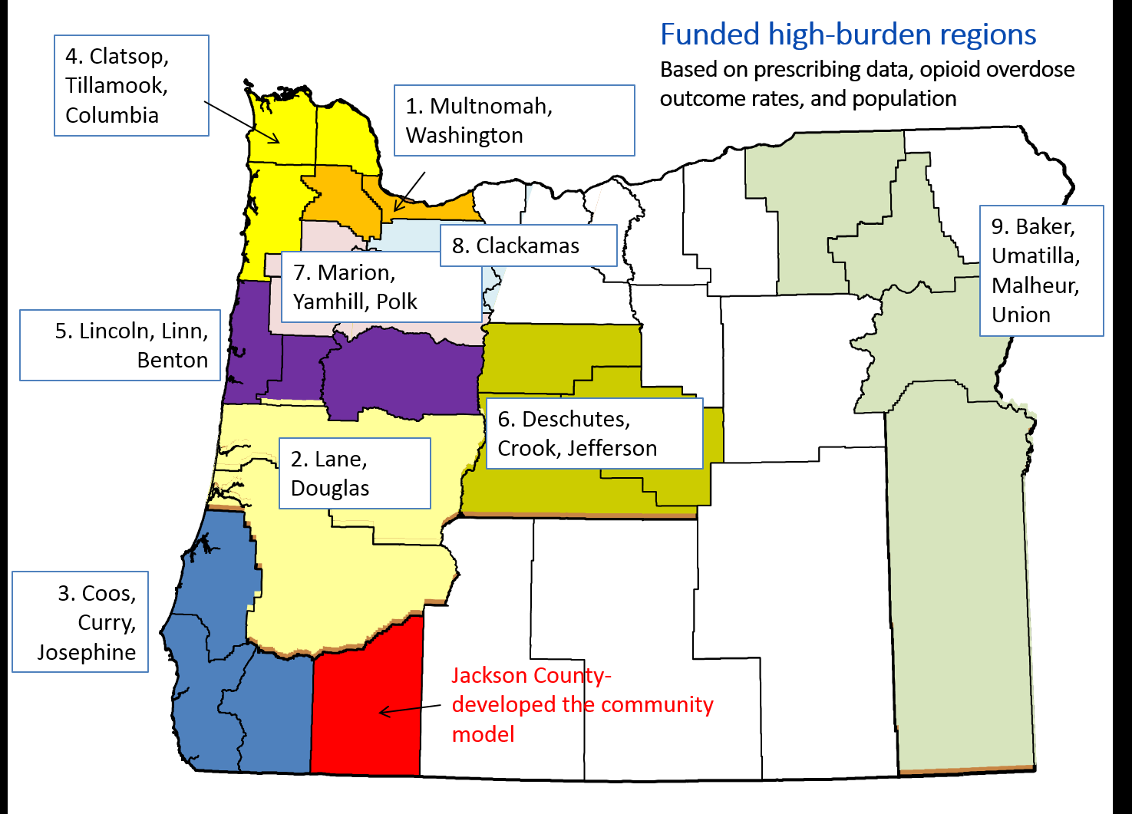

The Oregon regions with the highest burden of prescription drug overdose and problematic prescribing are:

- Portland Metro – Multnomah, Washington
- Lane, Douglas
- South Coast – Coos, Curry, Josephine
- North Coast – Clatsop, Tillamook, Columbia
- Linn, Lincoln, Benton
- Central Oregon – Deschutes, Crook, Jefferson
- Mid-Willamette Valley - Marion, Yamhill, Polk
- Clackamas
- Eastern Oregon – Baker, Malheur, Umatilla, Union

Red font is new to the September 2017 amendment for this PE

Program Element #27 - Prescription Drug Overdose Prevention (PDOP)
- Description. Funds provided under this Agreement for this Program Element may only be used, in accordance with and subject to the requirements, and limitations set forth below, to implement Prescription Drug Overdose Prevention (PDOP) activities in the following areas for LPHAs in High-burden Regions.
- Application of Prescription Drug Overdose Assessment and Capacity-Building Efforts. Complete remote (web-based) training on using the Oregon Prescription Drug Monitoring Program (PDMP) and PDMP guidelines.
- Advance Health System Interventions. Promote prescriber enrollment and adoption of the PDMP and state opioid prescribing guidelines. Three regions will works towards a goal of enrolling 95% of the top controlled substance prescribers in the region in PDMP over the two year funding period.
- Facilitation of Community Partnerships. Accomplish movement toward building or strengthening a community network within the region that contributes to reducing problematic prescribing, improving coordination of patient care for patients with opioid use disorder, increasing the use of non-opioid treatment for chronic non-cancer pain, and evolving a more interconnected community-level network of services.
- Facilitate Development of Local Prescription Drug Overdose Prevention Networks and Systems. Convene or strengthen an existing Interdisciplinary Action Team (IAT), a regional (or county-level) Pain Guidance Group (PGG) and a regional summit to help adoption and promotions of PDMP and opioid prescribing guidelines and increase community level data-informed awareness of PDO.
- Promote Community-Clinical Linkages to Support Prescription Drug Overdose Prevention. Disseminate local data or stories to local media outlets to promote public awareness of the burden and preventability of PDO.

- Definitions specific to this Program Element.
High-burden Region: an area of 2-3 neighboring counties led by a funded LPHA. The Oregon regions with the highest burden of prescription drug overdose and problematic prescribing.

Procedural and Operational Requirements.
- LPHA agrees to conduct activities in accordance with the following requirements:
- Implement activities in accordance with this Program Element;
- Assure that staffing is at the appropriate level to address all sections in this Program Element. LPHA will designate or hire a lead staff person to carry out and coordinate all the activities in the High-burden Region described in this Program Element, and act as a point of contact between the LPHA and OHA;
- Use the funds awarded under this Agreement for this Program Element.
- Attend all PDO meetings reasonably required by OHA. Travel expenses shall be the responsibility of the LPHA.
- Each High-burden Region must identify a LPHA to act as the fiscal agent for the High-burden Region. The LPHA will provide the workspace and administrative support required to carry out the grant-funded activities outlined in this Program Element.

- Reporting Requirements.
  - LPHA must have on file with OHA and approved Community Response Work Plan no later than October 1st of each year. LPHA shall implement its PDO prevention activities in accordance with its approved Community Response Work Plan. Modifications to the plan may only be made with OHA approval.

  - LPHA must submit quarterly progress reports.

  - LPHA must submit Oregon Health Authority Public Health Division Expenditure and Revenue Reports.

  - LPHA must submit PDO Expense Reports.

  - OHA will provide the required format and current service data for use in completing the plan and progress and budget reports.

- Program Evaluation. LPHA will cooperate with OHA on program evaluation throughout the duration of this Agreement period(s), as well as with final project evaluation.
Such activities may include, but are not limited to, meeting with a state level evaluator soon after execution of this Agreement to help inform the OHA evaluation plan, collecting data and maintaining documentation throughout this Agreement period, responding to evaluator’s requests for information and collaborating with OHA on final reports to highlight the outcomes of the work.

- Performance Measures. If LPHA completes fewer than 75% of planned activities in the description above, for two consecutive calendar quarters in one state fiscal year, will not be eligible to receive funding under this Program Element in the next state fiscal year.

