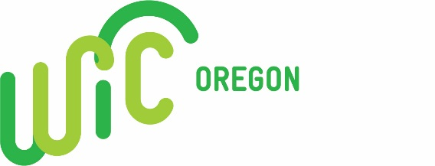 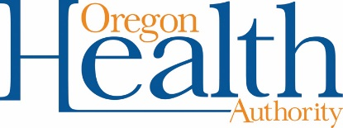

April 13, 2017

**FNS Funding for WIC Program General Infrastructure (GI) Projects**

USDA Food and Nutrition Services (FNS) has just released guidance for WIC GI funding for FFY 2017. A total of $500,000 is available to fund all approved projects in the western region. FNS will review state proposals and select projects for funding. Since one of the approved uses of the GI funds is to repair or renovate local agency facilities, the State WIC Program wants to invite current local WIC agencies (county health departments, tribes and non-profit entities) to submit proposals for these qualifying projects.

FNS allows each state to submit up to three (3) proposals. All proposals submitted by local WIC agencies will be considered and if more than 3 proposals are received, the State WIC Program will review and rank the proposals. Only proposals submitted with all required documentation will be reviewed. The top 3 ranking proposals will then be submitted to FNS for consideration.

**Types of Projects Funded:**

Repairing or Renovating Local Facilities: Projects to repair or renovate local agency facilities, including but not limited to the costs of repairing buildings damaged by natural disasters. This also may include the costs of setting up satellite or mobile clinics to deliver service to populations not effectively served through current locations, such as those in rural communities.

**Timeline for use of funds:**

Since these are FFY 2016/17 funds, FNS will extend the period of performance for these grants by one year, provided the funds are obligated by the end of FY 2017.

The termination date for these grants is September 30, 2018.

FNS will approve pre-award activities and costs from October 1, 2016 until the dates of award.

**Submission Requirements:**

Intent to apply

* Project title and brief description
* Amount of funds requested

GI Proposals

* Proposal Template including a detailed budget
* FNS Mandatory Construction Project Worksheet

**Timelines:**

**April 28, 2017** - Intent to apply (state submission is due to FNS May 2, 2017)

**May 11, 2017** - GI proposals and all required documentation (state submission is due to FNS May 15, 2017)

Oregon WIC will host a conference call to answer questions about this funding opportunity on Monday, April 24,

12-1pm. 1-888-278-0296, Participant Code: 605568